Continued Development of Wimblecomm

By:
Daniel Luis Soltren

Continued Development of Wimblecomm

An Interactive Qualifying Project
submitted to the Faculty of
WORCESTER POLYTECHNIC INSTITUTE
in partial fulfilment of the requirements for the
degree of Bachelor of Science

By
Daniel Luis Soltren

Date:
8-18-2018

Submitted to:

David Hall
Wimbledon Community Association
Susanne Ollig
Wimbledon Community Association
Professors James Hanlan and Gbetonmasse Somasse
Worcester Polytechnic Institute

This report represents work of WPI undergraduate students submitted to the faculty as evidence of a degree requirement. WPI routinely publishes these reports on its web site without editorial or peer review. For more information about the projects program at WPI, see http://www.wpi.edu/Academics/Projects.

Abstract
The Wimbledon Community Association (WCA) is a nonprofit organization that is currently operating an online venue hiring directory website called Wimblecomm. Several objectives and methods were chosen to address the question of how Wimblecomm can distinguish itself and increase its presence in the community. Based on findings obtained from this project, the Association would benefit from a more unified vision for the WCA distinct from Wimblecomm, initiating a social media campaign, hiring people with skills the WCA lacks, hosting a series of networking events, and identifying alternatives to the Wimblecomm venture.

Acknowledgements
I would like to thank the following individuals and organizations for their assistance and support throughout the course of my project:
- David Hall, Chair of the WCA, for organizing the interviews and tours that allowed me to gain insights that ultimately led to my recommendations. Also, for his guidance, hospitality, and willingness to engage with me during my attempts to extract meaningful information from the data.
- Susanne Ollig, Community Development Executive for the WCA, for her work disseminating my surveys online and vigorously pursuing community feedback. The number of respondents to the surveys would have been much less without her efforts. I am deeply grateful for it.
- Naomi Martin, Director of the Commonside Community Development Trust (CCDT), for her mentorship throughout the course of my project. Her comments on my drafts and research approach helped refine my analysis and development of recommendations. Furthermore, she offered advice beyond my project work and a general concern for my wellbeing during my time in London. I am fortunate to have been met with such hospitality and kindness.
- Roger Drage and Bill Lake, Trustees of the WCA, for their insights regarding the future of the WCA as an organization and Wimblecomm as a service. They offered unique perspectives that gave me a greater understanding of the value WCA could provide to the greater Merton area.
- Jackie Chapman, Secretary for the WCA, for her insights regarding the future of the WCA and Wimblecomm. Her enthusiasm toward the WCA and passion for community service showed during the brief time I spoke with her. It encouraged me to ensure that I provide the best recommendations possible.
- Professors Gbetonmasse Somasse and James Hanlan, London IQP Advisors, for their guidance and continued support throughout the entirety of my time in London and during ID 2050 last term (D-Term). Their constructive criticism allowed me to develop a valuable body of work and also grow as a person with respect to my public speaking skills.
- Jeff Gunn, Kate Holmes, Hilary O’Connor, Elizabeth Sharinger, Sorrel Parsons, Kate White, Jennie Peters, Jil Hall, Sylvia Lucas, Sally Warren, Beau Fadahunsi, and George Cook for their time and patience with me as I questioned them regarding their organizations.

Authorship
Juan Martin Hinostroza Tamayo – Juan contributed slightly to the initial drafts of the Introduction, Background, and Methods sections of the report during the ID 2050 course (D-Term).

Daniel Luis Soltren – Daniel contributed greatly to the entire report, in some cases writing the whole section. He also conducted all the interviews and wrote the associated case studies. The results and discussion section and recommendations section were written exclusively by him.

Table of Contents

Abstract iii
Acknowledgements iv
Authorship vi
Table of Contents vii
List of Figures xi
Executive Summary 1
Background 1
Methods 3
Results 4
Recommendations 5
Chapter 1: Introduction 6
Chapter 2: Background 8
The London Borough of Merton 8
Venue Hiring Practices in England and Beyond 13
The Wimbledon Community Association 15
Chapter 3: Methods 20
Examining the Business Model 21
Determining Wimblecomm’s Performance 22
Identifying Opportunities and Barriers to Outreach 23
Examining Social Impact Potential 24
Surveys and Interview Protocols 24
Recommendations 26
Chapter 4: Results and Discussion 27
Examining the Business Model 27
Determining Wimblecomm’s Site Performance 28
Identifying Opportunities and Barriers 29
Examining Social Impact Potential 30
Chapter 5: Recommendations 31
References 33
Appendix A: History of Philanthropy in England 36
Appendix B: Project Timeline 41
Appendix C: Case Study – South Wimbledon Community Association 42
Introduction 42
Evaluation 42
Summary 44
Appendix D: Case Study – Polka Theatre 45
Introduction 45
Evaluation 46
Summary 47
Appendix E: Case Study – Trinity United Reformed Church 48
Introduction 48
Evaluation 49
Summary 51
Appendix F: Case Study – Superhighways 52
Introduction 52
Evaluation 53
Summary 54
Appendix G: Case Study – South Park Gardens 55
Introduction 55
Evaluation 57
Summary 58
Appendix H: Case Study – Love Wimbledon 59
Introduction 59
Evaluation 60
Summary 61
Appendix I: Case Study – The Merton Voluntary Service Council 62
Introduction 62
Evaluation 63
Summary 64
Appendix J: My Community Space 66
Introduction 66
Evaluation 66
Summary 67
Appendix K: Trustee Meeting 68
Appendix L: Web Designer Meeting 70
Appendix M: Survey Results 71
Prospective Venue Provider Survey 71
Current Venue Provider Survey 81
General Public Survey 95
Appendix N: Interview Script 111
Appendix O: Survey Questions (Current Venue Providers) 113
Appendix P: Survey Questions (Prospective Venue Providers) 116
Appendix Q: Survey Questions (Current Venue Users) 119
Appendix R: Survey Questions (Prospective Venue Users) 121
Appendix S: Current Venue Provider Survey List 123
Appendix T: Current Venue User List (Part of General Public Survey) 124

List of Figures

Figure 1: Wards of Merton, London 7
Figure 2: Population Density in Merton in 2017 7
Figure 3: Merton’s Changing Age Profile 7
Figure 4: Merton’s Tenure in 2011 7
Figure 5: Indices of Multiple Deprivation 2010 7
Figure 6: White to BAME Ratio (Darker Areas Indicate Higher Proportion of BAME Residents) 7
Figure 7: Former Location of WCA (28 St. Georges Road, Wimbledon) 7
Figure 8: Map of Former Location of WCA (28 St. Georges Road, Wimbledon) 7
Figure 9: General Research Approach 7
Figure 10: Estimated Project Timeline for Events 7
Figure 11: Osterwalder Business Model Canvas 7

Executive Summary
The Wimbledon Community Association (WCA) is a Company Limited by Guarantee and registered charity serving the greater Merton area. They owned and operated a community center in Wimbledon until 2012 but closed the center due to increasing costs associated with day-to-day operations and building maintenance. Through a deal with the Merton Council, the new trustees invested capital from the sale of the premises and used the dividend toward funding the creation of a website called Wimblecomm. The purpose of the website is to facilitate connections between venue providers and venue users in Merton, as well as position the site as an “online community hub” to disseminate news and promote local networking. The WCA is committed to developing Wimblecomm into a viable platform for connecting venue operators who lack the resources to promote their venues and venue users who struggle to find local places to host events.
Two factors impede the growth of Wimblecomm: lack of community awareness and low engagement with venue providers. The goal of our project was to evaluate Wimblecomm’s current standing relative to similar organizations and find ways for Wimblecomm to better serve the Merton community. Our objectives included: examining Wimblecomm’s business model, conducting market research to gain insights from similar organizations that can be transferred to Wimblecomm, identifying opportunities and barriers for constructive engagement, and examining the WCA’s social impact potential. To accomplish our objectives, we audited the WCA’s business model, conducted interviews with key stakeholders and disseminated surveys among three target groups: current venue providers, prospective venue providers, and the general public. The conclusions drawn from our secondary research and feedback from the community was presented with recommendations for the WCA to apply toward the continuous development of Wimblecomm.

Background
The WCA was founded in 1946 by a Wimbledon-based group led by Sir Cyril Black MP. At the time of its founding, the general goal was to “promote the wellbeing of the broad community based around Wimbledon” (About WCA). The organization operated from a building located at 28 St. George’s Road, Wimbledon. Its corporate image emphasized non-party affiliation, non-sectarian, and non-discriminatory stances concerning all social matters. From the time of its opening until the year 2012, the center has served over 100 different groups. These groups would utilize the center space for various activities, including: self-help, leisure, educational, health, consultancy and sporting exercises.
Due to slowly increasing costs related to building maintenance and day-to-day financial operations, the community center was forced to close in 2012. Immediately after the closure, negotiations began that eventually concluded in a deal with the Merton Council in 2013. The Trustees used the capital resources realized from the sale of WCA’s share in the community center as a financial foundation for the future operations and activities. The capital was invested in a specialist fund aimed at charities and similar organisations (CCLA) and the dividend has been used to fund the administrative costs and services associated with the creation and maintenance of the organization’s new website, Wimblecomm (www.wimbledoncommunity.org). The website was formally launched in September 2016. Since then, the website and organization have continued to evolve to improve the efficiency and effectiveness of the services they offer.
The Annual General Meeting Minutes Draft for 2017 confirmed that the WCA does not yet have a structured development plan for Wimblecomm. In early 2018, to make improvements Wimblecomm sought assistance from a third party to review and make recommendations regarding how to optimize their web-based service for the community. Superhighways was hired to perform this task. Their mission statement is to “build voluntary and community organisations” ICT capacity, enabling more efficient and effective service delivery in the community” (Superhighways). In their final report they included the following recommendations:
- Review your mission and vision, be clear about your values so that you, and others, can make sound judgements as to whether your services are indeed valuable;
- Set your goals and business objectives (and / or develop an outcomes framework);
- Consider paid advertising with popular websites with big user bases such as Netmums;
- Develop a marketing/communications plan with smart objectives;
- Consider social media paid advertising – although referrals from social to the website are currently very low and Adwords is likely to yield higher results for search;
- Consider a quarterly eNews update for venue owners if not already doing so – sharing impact figures with them and directing them to best practice resources; and
- Clarify the vision for WCA going forward and why it's an exciting time to be involved with a growing digital charity – sell the benefits of being involved and specifically what they could contribute.
To address these issues, the goal was to conduct research and present a set of priorities in the form of recommendations for Wimblecomm to act on.

Methods
Our research focused on the following question: How can Wimblecomm distinguish itself in the marketplace and increase its influence in the community?
To address this question, we developed a series of objectives:
- Examine Wimblecomm’s business model for short and long-term vision as identified by Wimblecomm.
- Conduct market research to determine Wimblecomm’s performance relative to similar organizations.
- Identify opportunities and barriers to constructive engagement with stakeholders in the community.
- Examine the social impact potential of Wimblecomm toward facilitating creative engagement across greater Merton.

We used the following methods to satisfy our objectives: secondary research, surveys, and interviews. We applied secondary research to gather information regarding: business model strategies to transfer to Wimblecomm; number of venue-hire organizations in the local and national community; demographics of the people they serve; categories of venue spaces they offer; how they interact and attract people to their service (marketing strategies); and their performance metrics (i.e. the venue cost, how many times a venue is booked per week, month, and year, and what type of activity the venue space is used for).
Through data gathered by secondary research and the social network experience of our sponsors, we identified a set of stakeholders to disseminate surveys and conduct interviews. This approach increased our ability to locate individuals that were best fit to provide insight the WCA was seeking to improve its position as a leader in the community. See Figure 1 for a graphical representation of our research approach. Although interviews, surveys, and secondary research were applied to address each objective, secondary research was the primary data collection method for the first two objectives and interviews and surveys for the last two objectives.
Figure 1:General Research Approach

Results
After applying the research methods to address each of the objectives, the following results were observed:
- The revenue streams, customer relationships, and channels sections of the Osterwalder Business Model Canvas require further development for Wimblecomm;
- There are no “competitors” in the market other than My Community Space (www.mycommunityspace.com) that are nonprofit and function as an online venue directory service;
- According to Superhighways (See Appendix F: Case Study – Superhighways), the attributes being tracked for Wimblecomm on Google Analytics may not be tracking the most relevant information with respect to determining site performance;
- Wimblecomm lacks a user-friendly design that orients the user to the service being offered;
- Wimblecomm suffers from a lack of effective marketing;
- Venue providers and local organizations are interested in the success of Wimblecomm.

Recommendations
By examining Wimblecomm’s business model, conducting market research to determine its performance, identifying opportunities and barriers to constructive engagement with key stakeholders, and examining its social impact potential through the utilization of secondary market research, personal interviews, and surveys, the following recommendations were made:

- Develop a unified vision/identity for the WCA as an organization, distinct from the Wimblecomm venture;
- Initiate a social media campaign to increase awareness of the service offered;
- Invest in hiring individuals with skills the WCA lacks;
- Host a series of community networking events;
- Identify alternatives to the Wimblecomm venture, specifically other community needs that the WCA could take initiative in addressing.

Chapter 1: Introduction
Numerous nonprofit organizations, independent volunteers, and faith groups organize across England to address social issues relating to housing, poverty, and community development. Particularly interesting is the role of government in the social welfare of the people. Since the Elizabethan Poor Law was passed in 1558, a delicate relationship exists between the state and third sector in serving community needs. In recent history, the ascension of Conservative Party representation in Parliament has correlated with large reductions in government spending toward social welfare programs in general. The Big Society initiative, which emerged from the 2010 coalition Government of the Conservative and Liberal Democrat Parties, generally aimed to shift all responsibility for social welfare to the local community. This process is commonly known as “localism”. As a result, nonprofit organizations have been forced to develop creative solutions addressing community needs that are independent of government funding.
As one of those creative organizations, the Wimbledon Community Association (WCA) is a Company Limited by Guarantee and registered charity serving the greater Merton area. Founded in 1946, their original mission is to promote the “advancement of education and the provision of facilities in the interests of social welfare, recreation, and leisure time occupation for the inhabitants of Wimbledon and the surrounding area” (About WCA). They owned and operated from a community center in Wimbledon until 2012, but had to close the center due to increasing costs associated with day-to-day operations and building maintenance. Through a deal with the Merton Council, the new trustees invested capital from the sale of the premises in a specialist fund aimed at charities and similar organisations (CCLA) and the dividend has been used toward funding the creation of a website called Wimblecomm. The purpose of the website is to facilitate connections between venue providers and venue users in Merton, as well as position the site as an “online community hub” to disseminate news and promote local networking. The WCA is committed to the development of Wimblecomm into a viable platform for connecting venue operators who lack the resources to promote their venues and venue users who struggle to find local places to host events.
As part of their effort to improve, the WCA commissioned a third-party technical review of their site through a company called Superhighways. They audited the site and presented several recommendations regarding the Wimblecomm business model and methods by which the WCA collects site performance data. Superhighways found that the WCA should reexamine their “mission and vision” with respect to short and long-term goals for Wimblecomm. They recommended to refine Wimblecomm’s Google Analytics filters to extract more meaningful data to gauge site performance. In addition to the initial findings reported by Superhighways, Wimblecomm identified some concerns of their own. They are interested in developing a greater understanding of their “position” relative to other nonprofit organizations. The WCA also implemented a survey to gain insight regarding brand awareness and the community impact associated with their site.
Two major factors impede the growth of Wimblecomm: lack of community awareness and low engagement with venue providers. Even though Wimblecomm has around 30 providers and lists 77 venues, other venues exist that are not part of the network and many potential users in the community are not aware of the services the website provides. Site performance has been tracked since January 2017, indicating that Wimblecomm’s site activity is gradually improving but not at the desired rate. Wimblecomm has the potential to become a major resource for the community, since the absence of government funding increased the need for organizations to find ways to generate income. However, the lack of strong ties in the Merton community is hurting the WCA’s ability to advance the Wimblecomm agenda.
The goal of our project is to evaluate Wimblecomm’s current standing relative to similar organizations and find ways for Wimblecomm to better serve the Merton community. Our objectives include: examining Wimblecomm’s business model, conducting market research to gain insights from similar organizations that can be transferred to Wimblecomm, identifying opportunities and barriers for constructive engagement, and examining the WCA’s social impact potential. To accomplish our objectives, we will perform an audit of the WCA’s business model, conduct interviews with key stakeholders and disseminate surveys among four target groups: current venue providers, prospective venue providers, current venue users, and prospective venue users. The conclusions we draw from our secondary research and feedback from the community will be presented in a report with recommendations for the WCA to apply toward the continuous development of Wimblecomm.

Chapter 2: Background
The problem of how to effectively provide goods and services to disadvantaged groups has a long history in England, going as far back as the Elizabethan era (See Appendix A). In modern times the voluntary sector has transitioned into a mixed economy, with public and private nonprofit organizations providing services to those in need. Various factors such as local demographics and the fluctuating impact of government intervention influence the overall success of these organizations. In this section we will present an overview of the history of philanthropy in England, focusing primarily on the modern era (1900 – present). We will discuss the socio-economic condition of the London borough of Merton and the role nonprofit organizations have taken in the area. Several best practices in the delivery of volunteer services will be presented as they relate to the business model and service provided by the Wimbledon Community Association (WCA), also known as Wimblecomm. We conclude by describing in detail the challenges the WCA currently faces and how our research can provide some insight.

The London Borough of Merton
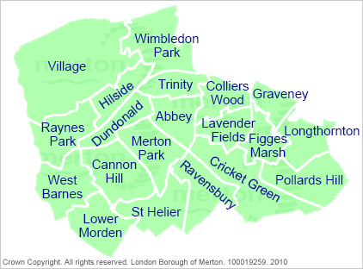
Merton was formed in 1965 by the joint merge of the Municipal Boroughs of Mitcham and Wimbledon, as well as the Merton and Morden Urban District. The borough is named after the historic Parish of Merton, which occupies the area now known as South Wimbledon (Merton). Merton is divided into 20 wards, with Wimbledon Village located in the northwest (See Figure 2). It is one of the more densely populated boroughs in London with an estimated population of 216,806 (Merton Council). The number of people living in Merton has increased by 6% over the last 10 years. Within Merton, the Colliers Wood ward has grown by 15 percent, the largest population increase of any ward (The Community Plan). The east wards of Merton tend to be more populous (See Figure 3 below). Merton Council is composed of 60 councilors, with 3 representing each ward. Following the most recent Council election on 3 May 2018, the Labour Party had 34 councilors enabling them to control the Council. The Conservative Party have 17 councilors, the Liberal Democrats have six councilors and there are three Merton Park Resident councilors. (Merton Council).
Figure 2: Wards of Merton, London
https://www2.merton.gov.uk/gif-wards.gif

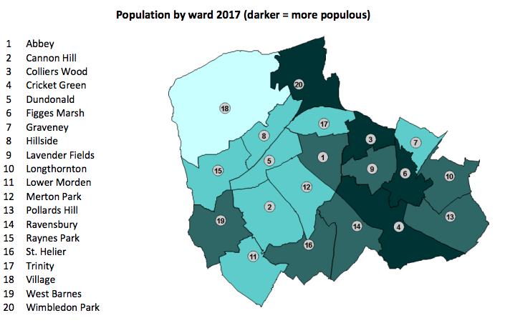
Figure 3: Population Density in Merton in 2017
https://www.mvsc.co.uk/sites/mertonconnected.com/files/Merton%202017%20demographic%20forecast.pdf

A significant feature of Merton’s population is the changing age profile of its residents (See Figure 4). Merton has a slightly higher proportion of children under the age of 5 years old: over the last 10 years the Trinity ward has had a 45 percent increase in this age group (The Community Plan). The elderly population of Merton is almost identical to that of London as a whole, with 1.6 percent of Merton’s population and 1.5 percent of London’s population over the age of 85, respectively.
Figure 4: Merton’s Changing Age Profile
https://www.mvsc.co.uk/sites/mertonconnected.com/files/Merton%202017%20demographic%20forecast.pdf
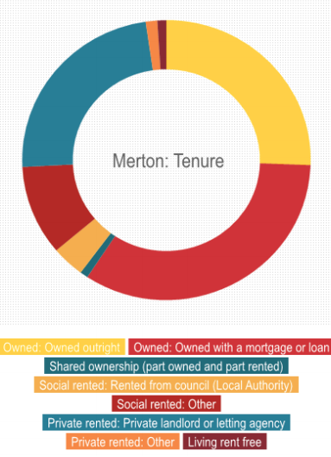
Merton is one of London’s most diverse boroughs, with over 35 percent of its residents having a Black, Asian, or ethnic Minority background (BAME) (The Community Plan). Merton Council found about 39% of the children and young citizens (CYP) in the Merton area are BAME. According to the Primary School Census, the top three spoken languages in Merton after English are Polish, Urdu, and Tamil. Merton residents’ top three foreign countries of birth are Poland, Sri Lanka, and South Africa.
About one-third of Merton’s population own at least one property and one-quarter rent from private owners. There has been a 67% increase in the use of private rented accommodation since 2001, with an overall 16% decrease in owned properties since 2001 (See Figure 5). This data “is likely to result in lower income households living in poor quality accommodation and rising homelessness” (Merton Demographic Forecast, Merton Council, 2017). According to deprivation figures, Merton is the fourth least deprived borough in London (Merton Council). Merton has a poverty rate of 20.3%, below the London average of 27% (Poverty and Inequality Data for Merton). Also, the unemployment ratio for Merton is under 4%. Other records from 2012 and 2013 offered by the Joint Strategic Needs Assessment (JSNA) in Merton mention that 4.64 percent of the 16-18-year-olds in Merton suffer from a lack of education, employment or training from the London borough, compared to 4.5 percent for London (Merton, JSNA). The JSNA also indicated that approximately 3,455 people were looking for Jobseeker’s allowance from the borough, which is lower than the total for London but higher than that of England. Life expectancy is higher in Merton than the London and England average, however there is a difference in life expectancy between the most and least deprived areas in the borough of about 9 years for men and 13 years for women (The Community Plan). Of the 15 least deprived wards in London, 3 are Merton wards: Village, West Barnes, and Dundonald. Within Merton, the 3 most deprived wards are Cricket Green, Figges Marsh and Pollards Hill (The Community Plan).
Figure 5: Merton’s Tenure in 2011
https://www.mvsc.co.uk/sites/mertonconnected.com/files/Merton%202017%20demographic%20forecast.pdf

For local politicians and community activists alike, an area of primary concern is the stark contrast between the east and west sides of Merton. According to The Community Plan, in 2013 the average salary in West Merton was £40,000 compared to £28,000 in the East. There is also a great difference in the proportion of residents on benefits, with 71 percent of residents in the east receiving benefits compared with 29 percent in the west. Regarding skill levels, 63 percent of working age residents in Wimbledon hold a degree, compared with 36 percent in the east. The east borough of Merton also has a greater proportion of BAME residents and is generally more deprived than the West (See Figures 6 and 7). To address these differences Merton Council developed its Neighborhood Renewal Strategy (Merton Council). Identified neighborhood regeneration areas include (mainly east of the borough): Lavender, Cricket Green, Figges Marsh, Ravensbury, Pollard hill, St. Helier, Longthornton, Graveney, Abbey, and Colliers Wood.
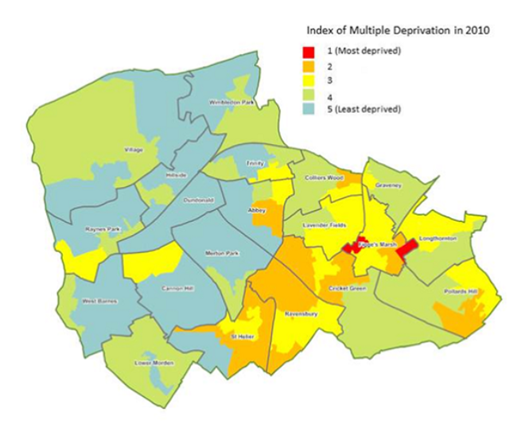
Figure 6: Indices of Multiple Deprivation 2010
https://assets.publishing.service.gov.uk/government/uploads/system/uploads/attachment_data/file/6871/1871208.pdf
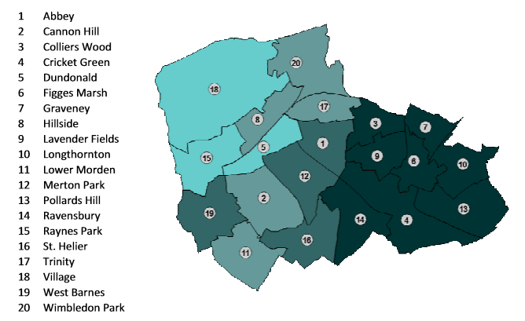
Figure 7: White to BAME Ratio (Darker Areas Indicate Higher Proportion of BAME Residents)
https://democracy.merton.gov.uk/documents/s2785/Appendix%202b%20-%20Demographic%20Information%20Report%2009012014%20Sustainable%20Communities%20Overview%20and%20Scru.pdf

Merton has a strong small business base, with 7,420 Small and Medium-sized Enterprises (SME) operating in the borough (The Community Plan). Merton Council identified 8 community centres serving the Merton area and estimate that 19% of the population of Merton are active volunteers (About Merton). There is an organization operating in Merton called the Merton Voluntary Service Council (MVSC) whose main goal is to foster an environment where “people’s lives are enriched by voluntary and community action” (About MVSC). There is a total of 917 active community, faith, and nonprofit organizations in the area (Strategic Review). Out of those 917 organizations, 58.9 percent of them are registered charities and 26.7 percent are companies limited by guarantee as of 2013.
The London Borough of Merton has a history of working with the voluntary sector. The Merton Partnership became a “platform through which organizations from all sectors work collaboratively” (Strategic Review). Through their efforts, nonprofit organizations have received support and numerous resources toward achieving their mission. Merton recognizes that the volunteer sector adds significant value to the social capital of the borough and, considering the current lack of public funding, is crucial in its ability to reach parts of the community that statutory social service providers struggle to serve. In this spirit, Wimblecomm intends to be an asset to the community by helping reach those underserved populations through their nonprofit organization.

Venue Hiring Practices in England and Beyond
Many non-profit organizations in UK are facing financial difficulties since the election and subsequent policies established by the Conservative and Liberal Democrat coalition government in 2010, which was followed by the election of a Conservative government in 2015. Following a further election in 2017 the Conservatives lost their majority and now lead a minority government supported by the Democratic Unionists of Northern Ireland. The Prime Minister is Theresa May of the Conservative Party. These governments have implemented a series of budget cuttings and policy systems that come along with consequences, which have taken a significant part in this struggle. For example, the “Universal Credit” is a benefit system, initiated in 2013 and enacted in 2017, which encourages citizens to be part of the labor force by offering them a chain of financial benefits from the government. It affects the economy of the self-employed, disabled, and families, but also place other people belonging to lower social classes in positions of debt, homelessness, and hunger (Butler, 2018). This and other types of governmental actions have been gradually driving the country’s economy from the public sector to the private sector and leaving non-profit organizations to meet some of the resulting gap in resources. For organizations with community centres, hiring their space has become an increasingly important priority. At the same time, they aim to help low-income people and groups find affordable spaces. Wimblecomm facilitates the service of venue hiring to both community centers/ non-profits and low-income venue seekers in a small and centralized community. However, there exists a variety of websites facilitating venues for hire that vary mostly in wealth and range of service coverage, and location, that can be compared to Wimblecomm.
Peerspace is one large profit venue facilitator since 2014 operating from Los Angeles, California that focuses on connecting people to luxurious spaces for business or social purposes. They count with spaces for hire around the United States and in three locations in Europe including London, and they also offer services in the areas of catering, rentals, and staffing (About, Peerspace). Their team consists of 30 members who have raised around $1.5 million only in their first year. The organization has accounts on five social media directories (Instagram, Facebook, LinkedIn, Pinterest, and Snapchat), and counts with a downloadable app in android and iPhone for easy access. In addition, more than twenty article publications about Peerspace have been made from big companies like Forbes, The Wall Street Journal, and BBC news (Press, Peerspace). This business clearly offers some insight into key features that make a service website successful in other parts of the world; however, there are also other organizations that operate as a charity rather than as a profitable business.
Flextila Joustotoimisto Oy is an organization of entrepreneurs that identify themselves as ecological community collaborators and focus on providing work environments. Through their website and their office in Helsinki they can connect space seekers to space providers and other proprietors (Company, Flextila). In order to encourage these space providers to join their website, they “offer booking calendar and payment system as well as Flextila marketing” (Smartsalo). However, they have only four categories of space services they offer, which is very narrow as compared to other venue hiring websites. They have price ranges going from free to some cost, their range of services goes around 22 countries in Finland, and they count with three social media accounts (Company, Flextila). This organization displays some key aspects that may help in developing a non-profit organization focusing on venue hiring; nevertheless, there are also other organizations that operate as a charity in the UK where there are more cultural similarities among the focus groups of Wimblecomm that can provide a more comparable model.
One of these is My Community Space which is a charitable organization operating from an office in Kent but has a virtual hub which stretches throughout all the UK. Their focus group is mainly “any charity, non-profit, or community group” (About Us, Mycommunityspace). The organization is distinguishable as it networks with other approximately 1,200 community organizations in the UK, and it counts with around 1,000 venues listed for hire. Therefore, the venues they list are mostly community spaces, which often target people on lower incomes. They have eight venue categories, and they only have one social media account (Facebook) (About Us, Mycommunityspace). Further inspections of these and any other further investigated organizations found to be similar to Wimblecomm will help the Wimbledon Community Association take measures for the enhancement of the website’s performance and missing key features.

The Wimbledon Community Association

The WCA was founded in 1946 by a Wimbledon-based group led by Sir Cyril Black MP. At the time of its founding, the general goal was to “promote the wellbeing of the broad community based around Wimbledon” (About WCA). The organization operated from a building located at 28 St. George’s Road, Wimbledon (See Figures 8 and 9). Its corporate image emphasized non-party affiliation, non-sectarian, and non-discriminatory stances concerning all social matters. From the time of its opening until the year 2012, the center served over 100 different groups. These groups would utilize the center space for various activities, including: self-help, leisure, educational, health, consultancy and sporting exercises.

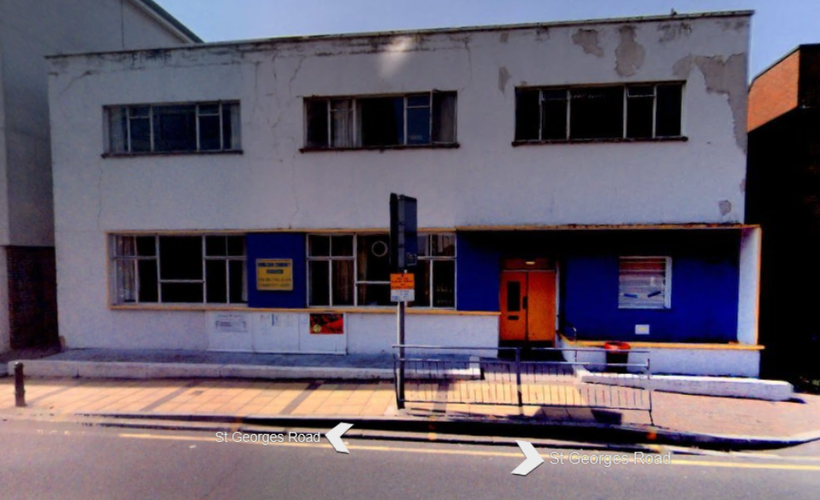
Figure 8: Former Location of WCA (28 St. Georges Road, Wimbledon)
Source: https://www.bing.com/maps

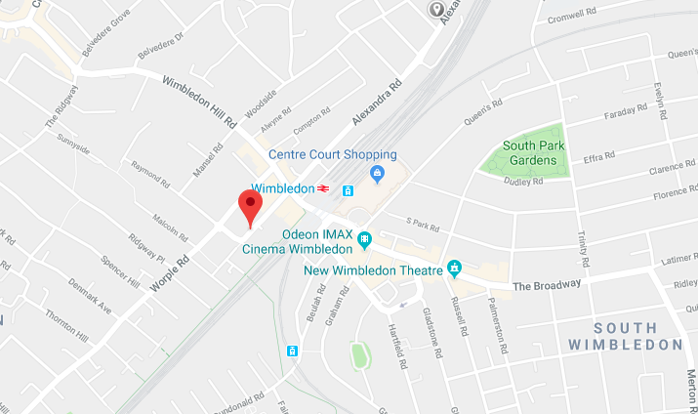
Figure 9: Map of Former Location of WCA (28 St. Georges Road, Wimbledon)
Source: https://www.bing.com/maps
Due to slowly increasing costs related to building maintenance and day-to-day financial operations, the community center was forced to close in 2012. Immediately after the closure, negotiations began that eventually concluded in a deal with the Merton Council in 2013. The Trustees used the capital resources realized from the sale of WCA’s share in the community center as a financial foundation for the future operations and activities. The capital was invested in the CCLA and the dividend has been used to fund the administrative costs and services associated with the creation and maintenance of the organization’s new website, Wimblecomm (www.wimbledoncommunity.org). The website was formally launched in September 2016. Since then, the website and organization have continued to evolve in an effort to improve the efficiency and effectiveness of the services they offer. Their current success has been achieved with the help of various organisations, including the CCDT, who have provided support on this current WPI project.
As of today, Wimblecomm functions as a facilitator between venues and venue seekers in the greater Merton area. They have 77 registered venues and 30 venue operators listed across the borough (David Hall, June 2018). The venues are used for a variety of purposes, such as:

- Social events;
- Meetings;
- Fitness classes;
- Artistic performances;
- Rehearsals;
- Competitions;
- Health classes;
- Self-help groups;
- Consultancies; and
- Sporting activities.
A recent analysis of the website’s performance by Google Analytics for the year 2017 showed that there were approximately 540 sessions per month, 2,250 page-views per month, and 390 users per month. The information also showed an increase between the months of August and November (Google Analytics, 2017).
Wimblecomm’s marketing techniques mainly rely on the use of social media with active Instagram and Twitter accounts, after the recent closure of their Facebook page. Although their Instagram account contains 3 followers, their Twitter account is more successful with approximately 318 followers, 186 tweets, and 22 likes. Wimblecomm is also present on several community websites such as Merton Council, neighborhood apps and other community organization pages (David Hall, 2018). In addition to social media outreach, the organization used other approaches:

- Flyers;
- Word of mouth;
- Presence at local events;
- Advertisements in the Metropolitan Community Church papers
- Affiliate marketing via third parties;
- Back links on key websites from the borough;
- E-mails to campaigns; and
- Surveys.
(David Hall, 2018)
After conducting a survey to determine the level of awareness and perception the greater Merton community has toward them, and conducting a self-review, the WCA trustees identified several issues at its Annual General Meeting in 2017. Some of the challenges they identified include:

- Difficulty in getting more volunteers to join help with the labor required since there is too much work to do for the limited amount of board members;
- Finding and convincing more venues to become members of Wimblecomm;
- Getting current members to promote Wimblecomm;
- Technical issues with web design;
- Need to improve and increase the number of skills from the trustees; and
- Getting the public to review their performance.

The Annual General Meeting Minutes Draft for 2017 confirmed that Wimblecomm the WCA does not yet have a structured development plan. In early 2018, to make improvements the WCA sought assistance from a third party to review and make recommendations regarding how to optimize their web-based service for the community. Superhighways was hired to perform this task. Their mission statement is to “build voluntary and community organisations” ICT capacity, enabling more efficient and effective service delivery in the community” (Superhighways). In their final report they included the following recommendations:

- Review your mission and vision, be clear about your values so that you, and others, can make sound judgements as to whether your services are indeed valuable;
- Set your goals and business objectives (and / or develop an outcomes framework);
- Consider paid advertising with popular websites with big user bases such as Netmums;
- Develop a marketing/communications plan with smart objectives;
- Consider social media paid advertising – although referrals from social to the website are currently very low and Adwords is likely to yield higher results for search;
- Consider a quarterly eNews update for venue owners if not already doing so – sharing impact figures with them and directing them to best practice resources; and
- Clarify the vision for WCA going forward and why it's an exciting time to be involved with a growing digital charity – sell the benefits of being involved and specifically what they could contribute.
To address these issues, it is our goal to conduct research and present a set of priorities in the form of recommendations for Wimblecomm to act on.

Chapter 3: Methods
The purpose of this project was to determine Wimblecomm’s current standing and how it can better serve the needs of the community. Our research focused on the following question: How can Wimblecomm distinguish itself in the marketplace and increase its influence in the community?
To address this question, we developed a series of objectives:

- Examine Wimblecomm’s business model for short and long-term vision as identified by Wimblecomm.
- Conduct market research to determine Wimblecomm’s performance relative to similar organizations.
- Identify opportunities and barriers to constructive engagement with stakeholders in the community.
- Examine the social impact potential of Wimblecomm toward facilitating creative engagement across greater Merton.

We used the following methods to satisfy our objectives: secondary research, surveys, and interviews. We applied secondary research to gather information regarding: business model strategies to transfer to Wimblecomm; number of venue-hire organizations in the local and national community; demographics of the people they serve; categories of venue spaces they offer; how they interact and attract people to their service (marketing strategies); and their performance metrics (i.e. the venue cost, how many times a venue is booked per week, month, and year, and what type of activity the venue space is used for).
Through data gathered by our secondary research and the social network experience of our sponsors, we identified a set of stakeholders to disseminate surveys and conduct interviews. This approach increased our ability to locate individuals that were best fit to provide the insight Wimblecomm was seeking to improve its position as a leader in the community. See Figure 10 for a graphical representation of our research approach. Although interviews, surveys, and secondary research were applied to address each objective, secondary research was the primary data collection method for the first two objectives and interviews and surveys for the last two objectives.
Figure 10: General Research Approach
The project timeline (See Appendix B) illustrates how we proceeded with our research and implementation of our methods. Unfortunately, some stakeholders were not available for interview. Final project deliverables included a research report with all gathered data and recommendations presented for the benefit and continued development of Wimblecomm.

Examining the Business Model
For the purposes of our project we modeled the WCA with Wimblecomm as a start-up company. We began our assessment by reviewing all documentation regarding the business strategy and practices put in place for Wimblecomm. We reviewed the WCA’s constitution, documentation detailing marketing strategies (i.e. advertisements, incentives, brand promotion campaigns, etc.), and milestones. To assist in our assessment, we used the Osterwalder Business Model Canvas (BMC). The BMC was initially proposed by Alexander Osterwalder based on his earlier work on Business Model Ontology (Designing Business Models and Similar Strategic Objects: The Contribution of IS, 2013). The BMC (Figure 11) is a strategic management and lean start-up template to assist entrepreneurs toward developing new or documenting existing business models. It is used to describe, design, challenge, and pivot a business model. It is particularly useful in identifying areas in business model plans where organizations can improve.

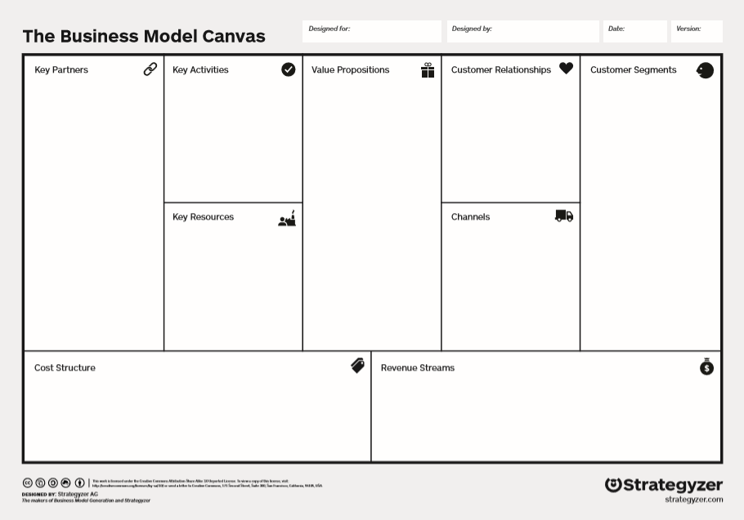
Figure 11: Osterwalder Business Model Canvas

To address our first objective, we reviewed and categorized all pertinent documentation into each of the applicable categories. We also used the business documents received from the organizations we toured and interviewed to extract meaningful information to transfer over to Wimblecomm. The BMC functioned as a guidance tool to help us determine whether the current Wimblecomm business model was complete and accurately described their plans to approach each of the business categories defined on the canvas. We also supplemented our analysis through interviews with board members of the WCA.

Determining Wimblecomm’s Performance
To achieve the second objective, we performed secondary research to identify organizations that are pursuing similar activities in the venue hire market according to their geographical location. Once identified, the sites were examined for business and marketing strategy concepts that show transferability potential for Wimblecomm to implement. Any information regarding website performance, total number of venue users/venue providers, indicators of profitability, etc. were recorded and used to benchmark corresponding data obtained from the WCA.
We analyzed the information to gain insight into areas where Wimblecomm was lacking and areas where Wimblecomm was performing well, with respect to what “peer” organizations were doing in the venue hire market.

Identifying Opportunities and Barriers to Outreach
For a company to grow, it is important to identify opportunities and barriers that advance the organization or prevent it from expanding. We focused primarily on determining what prevents Wimblecomm from attracting more venue providers and users to their website. Due to the wide variety of activities that venue spaces can be used for, every adult in the Merton area that has access to the Internet was a target, as well as all venue owners. We used secondary research to map areas in Merton where there is a high concentration of venues that do not have Wimblecomm membership and obtained their contact information through our sponsors for them to disseminate surveys and potentially conduct interviews. We specifically targeted organizers of sports, cultural, and other groups that are potential users of Wimblecomm. Our goal was to gather information regarding why these individuals and groups are not connected to, or familiar with, Wimblecomm’s services.
Our sponsors guided us toward reducing our set of potential survey recipients to a refined list. The venue providers and users were contacted primarily by e-mail. However, we contacted survey recipients by phone or in person on a case-by-case basis. The surveys varied according to the category the recipient was classified under. Once the completed surveys were returned, data was collected in Qualtrics for analysis and further development of recommendations. The Qualtrics platform was particularly useful due to the various question types offered, pre-made survey templates, and features such as logic branching, display logic, quotas, embedded data, email, triggers, mobile and offline compatibility. The survey software also allows for numerous dissemination methods, including anonymous survey links which were used to attach to emails and posted on the Wimblecomm website.

Examining Social Impact Potential
We inspected the social impact Wimblecomm has on different areas of Merton to find ways to maximize positive externalities and minimize the negative externalities. To accomplish this, we conducted interviews with key stakeholders. There were two target groups: current venue users and prospective venue users. Current venue users were identified by our sponsors. Prospective venue users were identified by secondary research along with guidance from our sponsors. We created a list of contact information for leaders of public spaces such as parks and community areas for groups of people performing leisure activities (such as sports, artistic rehearsals, etc.). Once we obtained a reasonable list of people, our sponsors disseminated the appropriate surveys via an e-mail containing a link to our survey for each of them to complete.
To supplement the data we received from surveys, our sponsors organized a series of qualitative interviews for us to extract information from. We wrote an interview script (See Appendix N) having a set of general research questions that addressed in part the community awareness of Wimblecomm and the willingness of citizens to engage with the WCA as a community organization.

Surveys and Interview Protocols
We worked alongside our sponsors in an iterative process to develop surveys and interview scripts primarily to satisfy objectives 3 and 4. We surveyed the following three groups of Wimblecomm clients and how we identified them:

- Current venue providers/members - identified by our sponsors (See Appendix S)
- Prospective venue providers/members – identified by our sponsors and secondary research
- General Public – identified by our sponsors and secondary research (See Appendix T for partial list of identified Wimblecomm users)

We developed the surveys in Qualtrics and disseminated them by e-mail and postings on the Wimblecomm website (See Appendix O – R) as well as other sites identified by our sponsors. Surveys Q and R were combined in Qualtrics under the title “General Public”, with an initial question asking whether the recipient whether they had used Wimblecomm before. The recipient was then guided to the appropriate set of questions. We also created an interview script and a set of general interview questions. Depending on the interviewee, we modified our question set as needed. Our focus group script also consisted of a general format and set of questions that was modified as appropriate given the members of the group.
We developed our systematic sample of stakeholders from data gathered during secondary research and information provided by the WCA. We obtained the contact information of venue seekers that are already working with Wimblecomm. Through our secondary research we developed a separate list of venue spaces in the greater Merton area and retrieved contact information from their websites. Our scope included churches, recreation centers, and any other relevant organizations. We submitted our final list of venue providers to our sponsors and, along with their list, they created a master list of contacts for survey dissemination. Our sponsors agreed to follow through with the process of sending the surveys out to our contact list. Our aim for surveys was to distribute them broadly to ensure we received the maximum amount of responses possible.
Due to the nature of our project, we did not hand out hard-copies of our surveys. Our sponsors emailed survey links to identified contacts within our group of stakeholders and waited for responses. The email contained a cover note explaining the nature of our research and the anonymity of their responses to our survey. We anticipated that responses may not come quickly or at all, therefore we explored the possibility of offering incentives for completing the survey. We ultimately decided it would not be necessary. The survey responses we received were stored on one of our personal laptop computers.
We developed our set of candidates for interviews based on recommendations presented by our sponsors. Through secondary research we identified members of the community (Merton Council members, councilors, city planners) that also had information that could assist Wimblecomm. The responses we received from our surveys were used in part to determine who to contact for follow-up interviews. We were interested in responses that showed a great discontent or a great satisfaction with Wimblecomm. Along with the recommendations provided by the WCA, the result was a filtered list of interviewees who could provide constructive criticism regarding Wimblecomm’s presence in the community and what it could do better for them as a stakeholder.
All interviews were conducted either in-person or over-the-phone. For in-person interviews, our sponsors arranged meetings with the interviewee in a location and time that was most convenient for them. Over-the-phone interviews were granted at the interviewees convenience, although in-person interviews were preferred. We primarily took minutes of the proceedings. Before the interview began, whether in-person or over-the-phone, we asked if the interviewee did not want us to record the meeting. If not, we proceeded taking minutes. It was anticipated that meeting notes were less time consuming than reviewing hours of audio and writing transcripts. The questions we asked were tailored to the knowledge and expertise of our interviewee(s). At the end of the interview, we asked the interviewee(s) to recommend other people with whom we should speak with. Key information was filtered from every interview to identify patterns and trends with respect to certain opinions made about Wimblecomm’s performance, where it was lacking, and what the organization could do to improve.

Recommendations
Based on the results from our analysis of the data retrieved through our research, we presented our findings in a report along with a set of recommendations for Wimblecomm. This information was used to establish a set of priorities for Wimblecomm to work toward their short and long-term goals.

Chapter 4: Results and Discussion

Examining the Business Model
After meeting with David Hall during the first week of the project, it was confirmed the WCA lacked a business plan for Wimblecomm. The need for serious thought regarding the short and long-term future of the website and the organization were clear after this meeting. During the 7th week of this project we forwarded the Osterwalder Business Model Canvas to David Hall to review and populate with responses. See Figure 12 below for a condensed version of his responses.

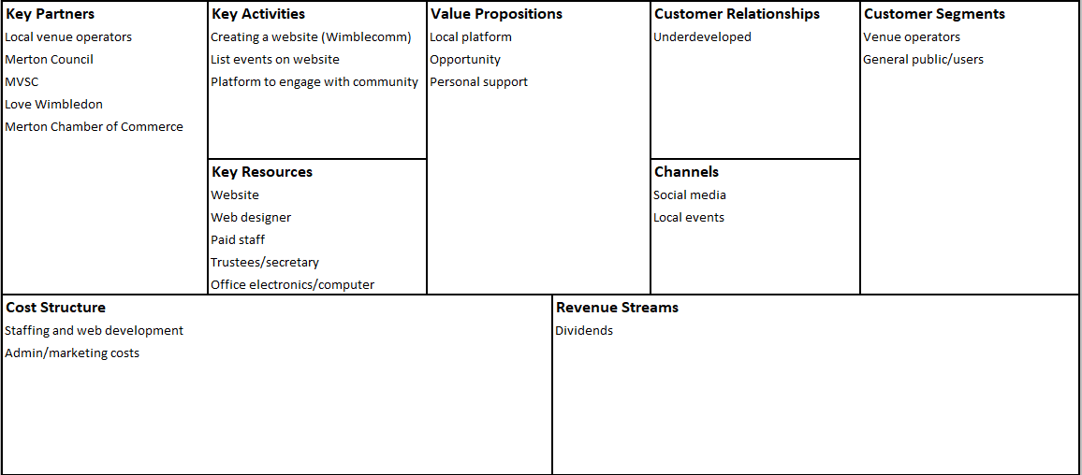
Figure 12: Completed Osterwalder Business Model Canvas (from information received from David Hall)

According to the responses given, the weakest areas are the Revenue Streams, Customer Relationships, and Channels sections. The main revenue source for the WCA is the dividends from the investment of the money from the original sale of its interest in the old community centre. As decisions are made regarding whether to invest in a physical space, hire a new web developer, or hire individuals to perform identified tasks, other forms of income must be identified for the long term. Under the Channels section, social media and local events are the main approaches for the WCA to connect their service to their consumer base. However, according to the survey results (See Appendix M) there is a lack of effective use of social media to increase awareness and attract potential users to the Wimblecomm site. Customer relationships are underdeveloped with the lack of generating effective methods for community outreach and promotion of the value added to the community regarding Wimblecomm. Results from the General Public survey demonstrate that point as well.
The Osterwalder Business Model Canvas is a tool used to assist an entrepreneur when “thinking through” each of the areas of an organization that require attention and an effective plan to address. It is also useful in identifying gaps in areas that may have a degree of uncertainty. With respect to this project, the application of the canvas model allowed my sponsor to identify formally on paper the areas that are lacking with respect to his venture, Wimblecomm. As stated above, the main areas that require attention are: customer relationships, channels, and revenue streams.

Determining Wimblecomm’s Site Performance
Attempting to determine where Wimblecomm stands in relation to organizations proved to be a difficult task given that there are no “competitors” in the market who are targeting middle-to-low income individuals on a borough-specific level. As mentioned in the background (2.2 Venue Hiring Practices in England and Beyond) there are several websites that function as an online venue hiring directory, but are either for profit or operate on a national level. My Community Space is the only website that aligns with Wimblecomm in the sense that it is a nonprofit and an online venue service directory. After conducting an interview with George Cook, Director of My Community Space (See Appendix J: Case Study – My Community Space) it became clear that the extensive business contacts, relationships, and personal wealth established during Cook’s previous business career grant him a unique position to identify opportunities where the WCA may not be aware or able to.
The WCA forwarded data they received from Google Analytics to track metrics such as number of site visitors over a period of time, number of clicks, etc. The general trend was that site activity was improving but at an extremely slow pace. During an interview with Sorrel Parsons from Superhighways (See Appendix F: Case Study – Superhighways), she stressed the importance of measuring the right attributes and questioned whether the WCA was indeed tracking the correct information to draw solid conclusions from. Once again, it was difficult to determine whether Wimblecomm is performing well with respect to the market. There are also several findings from the Superhighways report completed earlier in 2018 that identify what she called “classic web design mistakes” and that she was willing to work with the WCA to resolve if given the opportunity.
When venue providers were asked whether Wimblecomm has generated more, less, or the same as other organizations regarding the number of venue hires received, 75% said “greater than Wimblecomm” (See Appendix M: Survey Results). From the information received during interviews and the survey results, it can be inferenced that Wimblecomm as an online venue hiring directory is not performing at the level it should be.

Identifying Opportunities and Barriers
This objective was accomplished primarily from survey results and information received during the interview process. Each of the interviewees offered insight regarding their perspectives of Wimblecomm as a website and the WCA as an organization. Most of the feedback was favorable, with some organizations such as Love Wimbledon, My Community Space, and Superhighways offering themselves to be willing to work with the WCA in the future. Most of the criticism came regarding the website itself and its ability to orient the user to the service the website is intended for. The lack of an effective, user-friendly website was expressed by several of the interviewees which suggests that it may in fact be an issue.
Some of the main findings from the general public survey suggest that a lack of effective marketing is another barrier to the long-term success of the Wimblecomm venture. When asked if they have ever used Wimblecomm to look for a venue before, 86.05% of the respondents said no (See Appendix M: Survey Results – General Public Survey). The follow-up question posed to those who said no asked whether they have heard of Wimblecomm before, with 78.13% of the respondents said no. This information suggests a serious consumer relations problem. An inability to connect the service with its intended audience will ultimately lead to the failure of the venture in a short period of time.
An opportunity for the WCA to grow was identified when, during the general public survey, the respondents were asked whether they would attend an event hosted by the WCA. Of those who responded, 57.69% said yes and 42.31% said no. It appears to be a split issue with only little more than half of the respondents stating yes. A possible reason for this response is that the majority of the respondents never heard of Wimblecomm in the first place. It is logical that they would not be too intrigued with attending an event sponsored by an organization that they are not even aware of. However, there are also a decent number of people who would attend. This suggests that some form of community outreach could provide a platform for the WCA to identify with their target market.

Examining Social Impact Potential
Insights gained with respect to this objective came almost exclusively from the survey results. In the current venue provider survey, respondents were asked whether they have secured venue hires from the site and 75.00% of them stated yes (See Appendix M: Survey Results – Current Venue Provider Survey). Another question posed was whether the respondent believed that Wimblecomm provides a vital service to the greater Merton community. Out of the total number of respondents, 87.50% stated yes. When asked whether they would attend a community networking event, 71.43% of the respondents replied yes. These responses indicate that venue providers are interested in Wimblecomm’s success, because success for the website in terms of attracting more visitors will increase the chances of each of their venues being hired.
In the general public survey, for the individuals who responded “yes” to the question of whether they have used Wimblecomm to secure a venue space, 75.00% of them stated that Wimblecomm presents the type of venues they are looking for (See Appendix M: Survey Results – General Public Survey). When asked whether they were satisfied with the service provided to them by Wimblecomm, out of 4 respondents that answered the question, 100% of them replied yes. A follow up question was asked, providing an open text field for the respondent to indicate how Wimblecomm satisfies them. The two received responses indicated that Wimblecomm has a “good choice of venues” and that “all the details are in one place”. It must be stated that the number of survey respondents who actually used Wimblecomm to secure a venue was very small, so the percentages do not reflect what would be considered a good statistical sample size.
The main result gained from the survey feedback is that there is potential for Wimblecomm to grow, and there is a need in the community for the service. However, effective marketing and communication with the community of Merton is imperative for the WCA to move the Wimblecomm venture forward.

Chapter 5: Recommendations
By examining Wimblecomm’s business model, conducting market research to determine its performance, identifying opportunities and barriers to constructive engagement with key stakeholders, and examining its social impact potential through the utilization of secondary market research, personal interviews, and surveys, we have made the following recommendations:

- Develop a unified vision/identity for the WCA as an organization, distinct from the Wimblecomm venture

For the success of any start up organization, it is extremely important to have a clear vision regarding the short-term and long-term goals of the organization. It is also important for all the founding members to agree regarding the overall direction of the organization and the steps needed to make it to the end goal. The WCA chair and trustees should schedule a meeting to develop a short-term plan to advance Wimblecomm’s service and a long-term plan to determine the identity of the WCA in relation to the venture and as an independent, overarching body that oversees the Wimblecomm venture. During its initial stages, the Wimblecomm site functioned as an online venue directory and a community hub with respect to the noticeboard and guest blogs. The web site should be redesigned to focus exclusively on the service the website was created for and the “community hub” goal should be realized in another form.

- Initiate a social media campaign to increase awareness of the service you offer

The most valuable insight gained from the survey respondents was the fact that the general public is not aware of what Wimblecomm is. This is evidence of a poor community outreach strategy. To increase awareness, a social media campaign can assist toward that goal. Utilizing the information contained in the surveys regarding what forms of social media the respondents interact with most provides a starting point to focus outreach efforts on.

- Invest in hiring individuals with skills the WCA lacks

One of the key weak points in the structure of the WCA is the lack of personnel. With one chair and three trustees only, it is difficult to be able to dedicate the time and energy to fulfill the objectives of the organization. Along with the lack of “manpower’ there is also a lack of skills due to the mostly “business-orientated” academic background of the founding members. They lack individuals with technical and marketing skills to effectively move the Wimblecomm venture forward. Networking with local universities to attract students to help temporarily but on a continuous basis would be helpful. Also, if it is feasible, hiring more people could be beneficial as well.

- Host a series of community networking events

Almost every interviewee and survey showed positive indications that the WCA would benefit from hosting an event. Hosting an event would be effective in two ways: bringing people from different organizations and walks of life together and providing the platform for the WCA to make their “pitch” regarding the service they are offering with Wimblecomm. The key is to articulate to the people why Wimblecomm matters and why the WCA matters. Why should the Merton community be interested in what the WCA is doing? What value is in it for them? These questions can be answered at an event organized by the WCA.

- Identify alternatives to the Wimblecomm venture, specifically other community needs that the WCA could take initiative in addressing

The purpose of this recommendation is to remain focused on the long-term. The WCA is an organization and Wimblecomm is its sole venture. Wimblecomm does not define the WCA therefore alternative needs in the Merton community should be identified in case the Wimblecomm venture does fail. The future of the WCA rests upon its ability to continuously identify issues that they have the resources to solve. Toward that interest, creating a 5-year or 10-year plan can help. It is forward thinking that allows an organization to strive through hard times and persevere. Planning is always essential to growth. Identifying alternatives would benefit the WCA regardless if Wimblecomm is successful solely because it increases the number of options to grow as an organization.

References
About Us: My Community Space (n.d.). Retrieved April 23, 2018, from https://www.mycommunityspace.org.uk/
About WCA (n.d.). Wimblecomm. Retrieved from website http://wimbledoncommunity.org/about-wca/
Alcock, P. (2010). A strategic unity: Defining the third sector in the UK. Voluntary Sector
Review, 1(1), 5-24. 10.1332/204080510X496984 Retrieved from http://www.ingentaconnect.com/content/tpp/vsr/2010/00000001/00000001/art00002
Alcock. P, (n.d.). Third sector research centre working paper 82
A Review of WCA’s Business Model & Service Delivery in the Community (n.d.). WPI Project Proposal.
Beveridge, Lord. Voluntary Action: A Report on Methods of Social Advance. London: George Allen and Unwin, 1948.
Big Society Programme (n.d.). www.Gov.uk. Retrieved from Website https://assets.publishing.service.gov.uk/government/uploads/system/uploads/attachment_data/file/60548/building-big-society.pdf
Brandsen. (n.d.). Third Sector Policy Communities in Europe: A Comparison of the UK, the Netherlands and Sweden
Butler, P. (2018, January 25). Universal credit: What is it and what exactly is wrong with it? Retrieved April 23, 2018, from https://www.theguardian.com/society/2018/jan/25/universal-credit-benefits-scheme-iain-duncan-smith
Chapman, Jackie. (2017). Minutes of WCA annual general meeting 2017. (). London, England
Charity numbers fall leaving 'big society' pledge under threat. The Guardian (2011). Retrieved from
https://www.theguardian.com/society/2011/jun/05/charity-numers-fall-big-society
Clifford, D. (2012). Voluntary sector organisations working at the neighbourhood level in England: Patterns by local area deprivation. Environment and Planning A, 44(5), 1148-1164.
Coote, A. (2010). Cutting it: The ‘Big Society’ and the new austerity. London, New Economics Foundation.
Derrick Purdue. (2001). Neighbourhood governance: Leadership, trust and social capital. Urban Studies, 38(12), 2211-2224. 10.1080/00420980120087135 Retrieved from http://www.jstor.org/stable/43198195
Diamond, J. (2008). Capacity building in the voluntary and community sectors. Public Policy and Administration, 23(2), 153-166. 10.1177/0952076707086253 Retrieved from http://journals.sagepub.com/doi/full/10.1177/0952076707086253
Hall, D. (2018, March 22). Personal Interview.
Joints Strategic Needs Assessment (n.d.). Merton Council. Retrieved from website https://www2.merton.gov.uk/community-living/statistics/2011census.htm
Kendall, J., & Knapp, M. (1993). Defining the nonprofit sector: The united kingdom Citeseer.
McIntosh, M. K. (2005). Poverty, charity, and coercion in elizabethan england. The Journal of Interdisciplinary History, 35(3), 457-479. Retrieved from http://www.jstor.org.ezproxy.wpi.edu/stable/3657035
Merton 2017 Demographic Forecast. Merton Council. Retrieved from website https://www.mvsc.co.uk/sites/mertonconnected.com/files/Merton%202017%20demographic%20forecast.pdf
Month 1 to 12 (2017). Google Analytics
Open public services white paper (2011). Retrieved from http://www.publicinformationonline.com/download/23544
Our People (n.d.). Wimblecomm. Retrieved from website http://wimbledoncommunity.org/the-people/
P. Brian, Savage, O. (2013). The history of UK civil society. INTRAC Briefing paper 38. Retrieved from https://www.intrac.org/wpcms/wp-content/uploads/2016/09/Briefing-Paper-38-The-history-of-UK-civil-society.pdf
Peerspace. (n.d.). About us | connecting people with unique short-term spaces. Retrieved April 23, 2018, from https://www.peerspace.com/about#
Poverty and Inequality Data for Merton (n.d.). Trust for London. Retrieved from Website https://www.trustforlondon.org.uk/data/boroughs/merton-poverty-and-inequality-indicators/
Smartsalo. (2016, June 06). Retrieved April 23, 2018, from http://www.smartsalo.com/en/2016/06/06/joustotoimisto-oy-flextila/
Strategic Review (n.d.). Merton Voluntary Service Council. Retrieved from Website https://www.mvsc.co.uk/sites/mertonconnected.com/files/MVSC%20Strategic%20Review%202015-18%20Final_0.pdf
Superhighways (n.d.). Superhighways&nbsp. Retrieved from https://www.superhighways.org.uk/
Volunteering Overview (2017). UK Civil Society Almanac 2017. Retrieved from Website https://data.ncvo.org.uk/a/almanac17/volunteering-overview/
WCA AGM 2017 Chair Report and Survey Findings (2017). Wimblecomm. Retrieved from website https://wimbledoncommunity.org/wp-content/uploads/2017/11/WCA-AGM-2017-Chair-Report-and-Survey-Findings.pdf
Wimblecomm Community Association (n.d.). Wimblecomm. Retrieved from https://wimbledoncommunity.org/
WW2 People’s War Fact File: Beveridge Report (n.d.). Retrieved from
http://www.bbc.co.uk/history/ww2peopleswar/timeline/factfiles/nonflash/a1143578.shtml
Osterwalder, A & Pignuer, Y. (2013). Designing Business Models and Similar Strategic Objects: The Contribution of IS. Journal of the Association for Information Systems.

Appendices

Appendix A: History of Philanthropy in England
Throughout its history England faced numerous challenges toward defining a policy for providing services to the community. In the late 1500’s, English society was already grappling with the problem of how to best provide aid to disadvantaged peoples living in their community. In 1558 the Elizabethan Poor Law was passed, and the Statute of Charitable Uses was passed in 1601 (McIntosh, 2005). These laws stated that every parish must provide food, clothing, and shelter for the “legitimately needy” but also detailed forms of punishment to be used against those people who simply were “idle or vagrant poor”. Although later criticized for its “carrot and stick” approach, this law established England as the first European nation to formalize charity as part of governmental responsibility (McIntosh, 2005). It has also been interpreted as the beginning of the “secularization of philanthropy” (Kendall and Knapp, 1993) or, in other words, the shift in responsibility from the church to the state regarding charity.
As the country transitioned from an agricultural to an industrial economy during the 18th and 19th centuries, there was a corresponding migration from the small towns to the mill cities. This created a high concentration of individuals living in close quarters and made “increasing demands on both philanthropy and state” (Prochaska, 1988). The government’s lack of response toward addressing the growing inequalities encouraged volunteer groups to develop at the local and national level. Rose’s Act of 1793 recognized “friendly societies” of people who collectively raised funds to provide for the sick and the elderly, including burial costs for those who could not afford it (Campbell, 1911). These groups were associated with “the working spirit of self-help … by which that portion of the population which is most within the risk of pauperism endeavors to escape from it” (Beveridge, 1948). In 1834 the Poor Law was reformed to de-emphasize the government’s role in providing services for the needy and more toward punishing those “undeserving poor” with workhouses. The responsibility for serving the disadvantaged was placed on the voluntary sector (Kendall and Knapp, 1993). The 19th century also witnessed grassroots efforts of numerous individuals and groups advocating for social causes without help from government. These initial developments grew into what we would now call “professional non-profit organizations and voluntary service organizations” (Kendall and Knapp, 1993).
As England moved into the 20th century, the volunteer sector became more corporate as organizations gradually merged into larger groups with national reach. A charitable organization called the Guilds of Help was founded in 1904 to work toward strengthening the relationship between the state and voluntary sector. The Minority Report of 1909 established the concept of an “extension ladder, whereby the state provides a minimum threshold of welfare, to be topped up by the voluntary sector” (The History of UK Society, 2013). The first world war and the following economic depression forced local nonprofit organizations to work with each other toward the mutual goal of helping the greater community. The government also decided to play a greater role delivering goods and services to disadvantaged people. When the second world war commenced, the state and volunteer sector partnered “as manifested in the contributions of women’s groups, the Red Cross and Citizens’ Advice Bureaux” (Kendall and Knapp, 1993).
During the 1940’s, government intervention in social welfare increased through legislation providing public funds to support education, health, and rent control services. The 1942 report on Social Insurance and Allied Services, more commonly known as the Beveridge Report, was influential in developing the modern welfare state in England. One of the main purposes of the report was to provide an assessment of the socio-economic conditions of England after the second world war. Its author, Sir William Beveridge, was a social progressive who conducted a series of surveys in between world wars I and II. He believed that “social insurance fully developed may provide income security” (BBC). In 1945 Clement Attlee became Prime Minister, defeating Winston Churchill and striking a blow to the Conservative Party. One of Attlee’s first proposals was his announcement of the implementation of Welfare policies as described in the Beveridge report (BBC). Included in his Welfare policy was the creation of a National Health Service in 1948, as well as a “national system of benefits in the form of social security” (BBC). These policies solidified the role of the state in providing for its citizens “from the cradle to the grave”.
Increased government involvement complemented rather than diminished the role of the volunteer sector. According to Kendall and Knapp, the 1950’s and 1960’s saw “established [nonprofit] organizations pioneer(ing) new technologies … while many new organizations were formed, including innovative self-help groups, international aid and awareness agencies, and myriad sports and leisure bodies”. This trend continued into the 1970’s with the volunteer sector eventually playing the dominant role in social welfare. The limitations of the state became apparent as well. English government started to face criticism from community activists and other groups claiming the state should do more. In response the government funded “community-based groups and consumer and service user organizations to a much greater extent than before” (Kendall and Knapp, 1993).
As increased government spending exposed the limitations of state sponsored social welfare, a new Conservative government was elected into office with Margaret Thatcher acting as Prime Minister from 1979 to 1990. Under her leadership she committed to reducing all forms of government assistance, thereby leaving philanthropic efforts in the hands of private citizens and nonprofit organizations. During the late 1970’s and 1980’s the “charity sector” gave way to the “incremental legitimization and consolidation of the voluntary sector” (The History of UK Society, 2013). In 1978 the Wolfenden Committee presented a report titled “The Future of Voluntary Organizations” which anticipated the rise of voluntary organizations as liaisons between the state and third sector. Brandsen stated that “justification for strengthening a horizontal policy architecture centred on the idea of ‘intermediary bodies’ at the local and national levels” (The History of UK Society, 2013). This marked a gradual shift from the Welfare State to a mixed economy of welfare.
In the early 1990’s, framework agreements between the government and nonprofit organizations, known as “compacts”, were developed. Compacts were an offshoot of the “concordat” presented by the Deakin Commission and established by the National Council for Voluntary Organisations in 1996 (The History of UK Society, 2013). The Labour Party first proposed this concept in their “Building a Future Together” report in 1997. Compact agreements raised the status of third sector organizations to “corporate partners”, thus assisting the state in managing and determining social policy. The government functioned as a financer, coordinating and allocating funds to voluntary organizations and the organizations developing the “service design and delivery” (The History of UK Society, 2013). This policy also implied that the state and third sector were sharing responsibility for the efficient delivery of goods and services in the community.
This conservative approach to social welfare continues to this day, most recently manifesting as the “Big Society Programme” published under the 2010 - 2015 Conservative and Liberal Democrat coalition government. The publication states that “only when people and communities … take more responsibility can we achieve fairness and opportunity for all” (Building the Big Society, n.d.). They proposed a 5-point policy plan with objectives that include “encouraging people to take an active role in their communities” and “transferring power from central to local government”. This shift in policy increased the burden for social services to be provided independently by the volunteer sector.
The UK coalition elected in 2010 had to come to terms with a “significant and challenging policy legacy” (Alcock, 2012) implemented and refined by the Labour governments of previous decades. In their proposal, the “Big Society” was meant to oppose the “Big Government” approach to social welfare. A greater responsibility was placed on private citizens and nonprofit organizations to improve the overall conditions of their communities. According to the coalition, this would “return power from the state to the citizen” (Alcock, 2012).
Considering these changes, there is speculation that the Conservative policies are part of a long-term strategy to avoid or completely abandon government intervention into the welfare of its citizens. It was an immediate priority for the new government, with the incoming Prime Minister and Deputy Prime Minister making speeches advocating the Big Society as a centerpiece of public sector reform (Alcock, 2012). The Cabinet Office policy base established under the Labour administration, the Office of the Third Sector (OTS), was renamed to the Office for Civil Society (OCS). The Open Public Services White Paper detailed plans highlighting the need to “decentralize” public service delivery. In other words, the coalition, led by former Prime Minister David Cameron, advocated the expansion of the role of private and third sector organizations as provider agencies. The Work Programme was also launched to “support people who are at risk of becoming long term unemployed find work” (The Work Programme). However, almost all of the contracting agencies were “large private companies, with smaller third sector providers expected to become involved only at the level of sub-contractors” (Alcock, 2012). These actions and policies are perceived by many on the left as undermining the legitimacy of the Welfare state.
Another troubling development for the voluntary sector is the ongoing reduction in government spending on social welfare. The 2010 Spending Review detailed the commitment to remove the public expenditure deficit through a series of spending cuts in social programs totaling 25 percent (Alcock, 2012). The OCS and Cabinet Office received approximately 60 percent in spending cuts and resulted in the closure of several social programs such as Future-Builders and Change-Up. Among those most affected by the cuts were local government budgets. The Spending Review details that local authorities would face budget reductions anywhere between 10% to 25% over a period of four years (Alcock, 2012). This has a direct effect on nonprofit organizations since local governments usually provide them financial support.
Spending cuts have also created a “crisis of confidence” with the state facing criticism for failing to implement “relevant practices and policies” (Briefing Paper 38, 2013). According to the Guardian, in 2011 “the total number of registered charities fell by over 1,600 and the number of mergers increased by 150% during the first year of the coalition government” (Charity Numbers Fall, 2011). Labour Party representatives have frequently stated that the Big Society is ideologically aligned with Labour’s principles of “localism, mutualism, and collectivism”, but that the coalition has no plan to bring the concept to fruition. Most available data suggest that the government has pursued policies that hurt rather than helped the third sector (Briefing Paper 38, 2013).
It is in this economic environment that our sponsor organization, the Wimbledon Community Association (WCA), operates in. The WCA is a Company Limited by Guarantee (No. 03825493) and a registered charity (No. 1097305) focused on providing affordable venue services to the citizens of greater Merton. Their main purpose is to “promote the advancement of education and the provision of facilities in the interests of social welfare, recreation, and leisure-time occupation …” (Trustee Co-optee Specification). The WCA functions as a liaison between individuals looking for venue space and organizations willing to offer their venue space for use. Their community outreach strategy is based primarily on the promotion and development of their website (www.wimbledoncommunity.org). Through this website they aim to assist as many people as possible toward locating the community spaces they need for little to no cost. The website also functions as a marketing tool for venue providers who struggle making their venue space known to the public. The local focus of Wimblecomm’s service contrasts the mainstream national venue-hire websites whose main customer segment is the wealthy and affluent. Wimblecomm’s goal as a service provider is to increase the well-being and livelihood of the greater Merton area and develop ways to increase its effectiveness at facilitating this service for the community.

Appendix B: Project Timeline

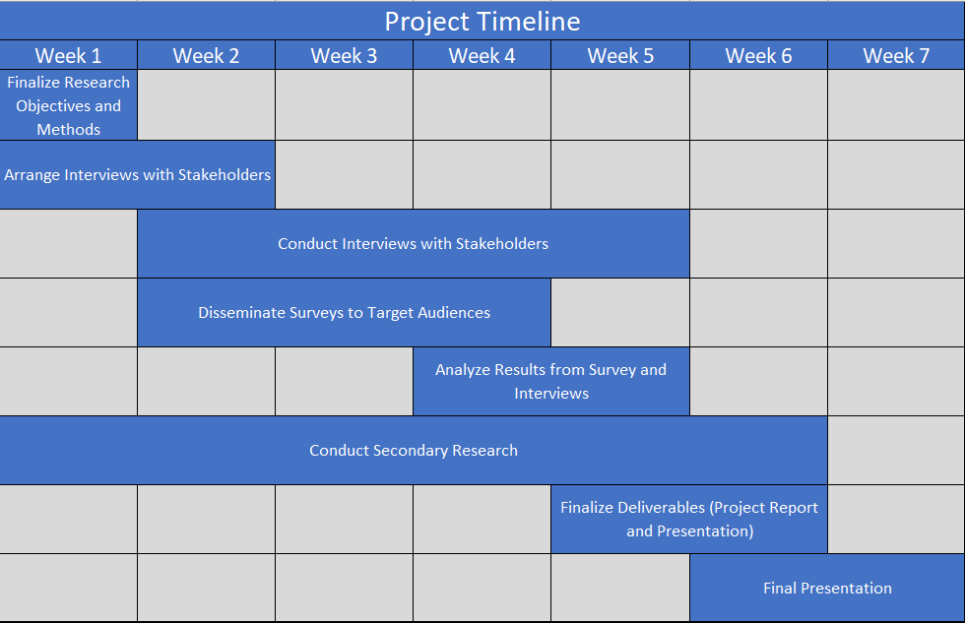
Project Timeline for Events

Appendix C: Case Study – South Wimbledon Community Association

Introduction
The South Wimbledon Community Association (SWCA) is a registered charity that focuses on providing low-cost venue space to the Wimbledon community. They have three primary venues available for hire: the South Wimbledon Community Centre (SWCC) which includes the Annex Building and All Saints School Hall, and another building located on 3 Pincott Road. Each of these venues have strengths and weaknesses that vary according to the needs of the user or user group. Some of the clients who hire space include: ethnic and faith groups, children’s activity groups, theatre and dance groups, and fitness groups. The SWCA prides itself on promoting diversity and equal opportunity for groups in all areas of the Wimbledon community to get involved with local activities and hire space at their sites. The SWCA is managed by a board of trustees and is a member of the Federation of Merton Community Centres.
The SWCC is operated by trustees who formally meet approximately every two months. The main positions include the Chair, Vice Chair, Treasurer, and Secretary with the current chair position held by Jeff Gunn and Vice Chair by Harry Todd. The organization offers a membership plan to interested community members that includes several benefits, such as: discounts on room hire rates and deposit, free newsletter, and discount membership prices for hiring space. All their facilities have convenient amenities such as ramps for wheelchair accessibility, disabled toilet facilities, baby changing facilities, and at Victory Road car parking facilities. The main rooms of the Patterson Annexe also have hearing loop systems for the hearing impaired.

Evaluation
The primary goal of conducting an interview with the chair of the SWCA Jeff Gunn and Office Administrator, Kate Holmes was to gain insight into how the organization operates from a business perspective. Of importance was how they communicate the value of their service to the greater Wimbledon community and further the sense of unity among disconnected groups in the ward. When asked what the mission of their organization was, they explained that they lease property from Merton Council on long term leases in excess of 20 years on favorable terms, but Merton Council have the right to terminate such leases at 6 months’ notice. These are the same terms that all community centres operate on throughout Merton. This and agreements to manage rentals outside school hours at the All Saints School constrain SWCA and their users and generally there is a lack of hiring space in Merton especially at peak times.

Jeff mentioned that the SWCA board consists of twelve trustees and occasional volunteers, whose services are mostly seamless to the public since they do not provide activities directly. That is done by over 30 user groups who are all members. The value they provide is through the facilitating of others by providing ongoing affordable access to rooms for these groups and individuals. The main decision makers that SWCA must convince about the value of the services that they provide is Merton Council. They monitor usage of facilities and when they terminated the lease on Merton Hall provided smaller but well fitted out facilities at 3 Pincott Road to assist with reducing any deficit on community facilities for hire in Merton. Of course, SWCA also must convince existing customers to switch venues and to attract new customers and whilst this takes time other factors such as location, ceiling heights, room sizes and parking facilities are important.
The strategy used by the SWCA to promote their service is primarily word of mouth and a set of posters placed on a noticeboard in front of and inside all their facilities. They also have their own website and advertise on other websites such as Netmums and the Merton Council site. They also have a staffed office with telephones on weekdays between 9:00am and 1:00pm to assist with bookings and make arrangements for potential customers to come and see their facilities. SWCA assisted two local organisations to become established over the past 5 years, The Friends of Haydon’s Road Recreation Ground and the Battles Area Resident's Association. They did this mainly through free use of rooms for a limited period of time and also with some leaflets and fliers that publicized their meetings. These community outreach campaigns meant greater footfall at their Victory Road facility and this has meant additional bookings from these organisations and their members because they have come into their facilities and seen posters and other advertising. SWCA have gaps in their bookings but not usually at peak times. They would like to operate at closer to full capacity especially at 3 Pincott Road but feel that traditional advertising and marketing are not appropriate as many enquiries currently received relate to time periods when they have no availability. Getting the right fit with users takes time and the welcoming approach by their staff is a form of low level marketing.
They do offer incentives to hire space for those who are already familiar with them. Members receive a 5% discount off each room hire and a £50 reduction in initial deposit (price reduced from £150 to £100). The value with this approach lies in its encouragement of the utilization of their building spaces and creation of competition with other organizations that offer spaces for hire. The quality of the spaces themselves are excellent for community facilities. Indeed, the Patterson Annexe received a 5* rating for kitchen hygiene from Merton Environmental Services. SWCA accept they do not currently have availability for some larger hall users for functions such as Weddings as they are catered events and The All Saints School do not allow any event that requires food or drink. Consequently, this is not part of their current target market. SWCA have an agreement in principle to manage the new senior schools’ facilities being built on the High Path Estate, outside school hours, reflecting the high regard that SWCA have in the community and with decision makers. This does not solve the catered event larger venue issue as they will impose the same restrictions as the All Saints School.

Summary
SWCA are a local community organisations and have met serious challenges to their operations over the last 5 years. Full on marketing would have been a total waste of money and whilst their trustees and management team are prepared to have low or no cost listings elsewhere such as Wimblecomm, marketing Merton Hall would mean marketing a closed or blighted building. SWCA have been involved in outreach projects to engage with the local community and indeed potential customers and this approach has worked for them so far but may not be appropriate for other organisations with a different business model or facilities.

Appendix D: Case Study – Polka Theatre

Introduction
Polka Theatre is a children’s theatre in Merton for children aged approximately from 0 to 12 years old. It is a registered charity and an Arts Council England National Portfolio Organization. The building contains two performance spaces: one 300-seat main auditorium and one 70-seat studio for “early years” performances. It functions as a producing and presenting theatre that also tours performances nationally and internationally. The building also features a creative learning studio, a garden, an outdoor playground, an indoor play area, exhibition spaces and a café. It is funded by Merton Council as well as several private charitable trusts and foundations, commercial companies and individual community members.
Polka Theatre began as a touring company in 1967 under the directorship of Richard Gill. With his vision, by 1971 the theatre was attracting audiences on tour numbering 250,000 each year. In 1976, Polka Theatre found the Holy Trinity Hall in Wimbledon, acquired it, and converted it into a children’s theatre. The theatre formally opened on 20th November 1979, the first venue dedicated exclusively to children. It was unique in its child-centered design and quickly became popular within and beyond the London area. At the time, its annual program consisted of seven homemade productions. By 1983 it was regularly programming and producing productions aimed specifically at children under the age of 5. Known as the Adventure Theatre, to this day it remains the only theatre space dedicated exclusively to productions for “early years” audiences.
In 1988 Vicky Ireland was appointed as the Theatre’s second Artistic Director. Under her guidance in 1991, the Theatre received a 75% increase in Arts Council revenue funding. The quality of the productions also broadened with respect to both content and form. Many biographical and historical dramas were now being performed, including: Rosie Blitz, Dreams of Anne Frank, and Playing from The Heart. In 1994 Polka Theatre won the Vivian Duffield Theatre Award to pursue an audience development initiative called “Curtain Up!”. The purpose of the program was to offer free theatre tickets to children from disadvantaged communities. The program is active to this day and is estimated to have brought over 30,000 schoolchildren to the theatre who may not have had the financial means to attend otherwise.
As of today, the Polka Theatre continues to provide innovative, quality theatre that continues to be relevant for its young audiences. It is a local theatre in the sense that it provides services for the local community, but also known internationally for the pioneering vision relating to the services it offers for children engaging in the arts. Learning and participation is one of the primary foundations for the work done at Polka, with the broad goal of encouraging children to explore and be creative. Their most recent initiative, Polka LAB, will support the professional development of three companies or artists per year who are interested in creating innovative children’s theatre. Over 90,000 children visit Polka every year, often for the first time. It has seen more than 3,500,000 visitors in the 39 years since the opening of its Wimbledon location.

Evaluation
An interview was conducted with the Head of Operations, Hilary O’Connor, to obtain information regarding the relative success of Polka Theatre and how it maintains its community support. She provided a brief overview of the mission and purpose of the organization, which is to “reach out and engage children in the arts, instilling confidence and sparking the imagination of children” (Polka Theatre Interview). She described how the Theatre provided a friendly and safe environment for children’s engagements, including event spaces and activities such as the “reading corner”, “dressing up” box, coloring, playground, café, and garden. When asked if they offer memberships, Hilary replied they did not, but that it might be a possibility in the future. Regarding any other incentives she stated that they offer free workshops to local schools which suffer from a lack of funding. They also offer lower ticket rates for schools in general and mentoring for students interested in the performing arts.
Although lacking a membership policy, the pro bono services it offers allows Polka Theatre to maintain interest and awareness of the services they offer as an organization. By providing a glimpse into the Polka experience, it encourages children to become involved and participate in the activities the theatre operates and potentially buy tickets to theatre performances. In addition to the “word of mouth” promotion they gain from their community service, Hilary stated they also send brochures to schools and the general public, pay for posters on bus stops, advertise on websites such as Love Wimbledon, and send emails to a qualified list of contacts identified by their marketing department. The fact that they have a marketing department was quite revealing of the importance Polka Theatre places on connecting the services they offer to the intended audience.

Summary
Polka Theatre is an established organization with longevity and experience on its side. The main service they provide to the community is unique in the sense that there is no competitor to drive away users of the events and activities they promote. They understand the value of outreach, regardless of how well their “brand” is recognized on the local or national level. With respect to outreach, they have a marketing department that focuses exclusively on connecting their offerings with the people. The division of labor allows Polka Theatre to dig deeper into issues such as finance and innovation. The most distinctive feature of Polka Theatre is its willingness to reinvent itself by creating new plays, activities, and events to maintain community interest.

Strong community ties are an indicator of community support which in turn validates the existence of the organization in the first place. If a community-oriented organization does not understand the needs of their community, they will offer services the community does not necessarily want. The ultimate result is failure for the venture. Although Polka Theatre has the advantage of being a sole provider of children’s theatre in the area, other nonprofits can learn from the incentives and outreach strategies it uses to achieve its mission. The general success of Polka Theatre, quantitatively evidenced by continuously selling out events and qualitatively demonstrated by the positive feedback from the community, shows that their approach to community service works.

Appendix E: Case Study – Trinity United Reformed Church

Introduction
The mission statement of the Trinity United Reformed Church is: rooted in Christ, growing in faith, sharing and serving in love. On October 30th, 1883, a dozen or so people met at the home of Patrick Kidd. They were interested in forming a “Scotch Church” in Wimbledon. As a result, a “preaching station” was formed by Presbytery and this was named Trinity Presbyterian Church. In 1887 Reverend William Maxwell was inducted as the church first minister of service. Under Maxwell’s leadership Trinity grew to a membership of roughly 160 people. During this time a site for the Church was found on Mansel Road and work began promptly. The building was finished in May 1886 and the congregation moved there from the Drill Hall. Then, in 1890, work began on the building of the church itself – it was dedicated on 30th April 1891. The buildings – hall, church and organ – cost £8170.
Trinity’s congregations and membership continued to grow. There was a strong ‘Scottish feel’ to the church, with many of the church’s members being exiled Scots. Sunday School was held in the afternoons. The Guild provided a program of social and educational events. The choir was large and popular, singing at both Sunday services and holding regular concerts. Sales for foreign missionary work were held annually.
By 1922 Trinity had reached a membership peak of about 340. Over the coming years the congregations and membership were to decline, and the Sunday School shrank from over a hundred children to under forty. Dr Macgregor had proved a fine minister, but it became clear that a younger man was required. In 1930 he retired at the age of seventy-two, having been Trinity’s minister for thirty-five years.
As of today, Trinity is a culturally diverse congregation made up of all ages, and of many backgrounds and personal perspectives. They strive to be an inclusive and welcoming church, believing that God calls and invites us – in all our variety of ages, nationalities, views and traditions – to be united in Christian fellowship and discipleship together. Trinity is a local congregation of the United Reformed Church, a mainstream Christian denomination in the UK which has its roots in the Presbyterian, Congregational and Churches of Christ traditions. The United Reformed Church (URC) nationally combines its commitment to the Reformed tradition with a passionate belief that all God’s people should be one. It seeks to work with Christians of all traditions, and celebrates being part of many Local Ecumenical Partnerships, with churches of other denominations. The URC is committed also to theological and cultural diversity, rejoicing in the gifts of members from across the world, and seeks to hold together people whose varied insights helps the church understand the wonder of God. Worldwide, more than 70 million Christians are members of the Reformed family of churches.
In addition to their religious platform, Trinity offers their church, halls and meeting rooms for hire for business meetings, training sessions, children’s parties, concerts, lectures, as well as any other occasions. According to their website (Premises Hire, www.trinitywimbledon.org), incentives to hire space at Trinity include:
- Convenient town-centre location
- Town centre car parks within walking distance
- Excellent public transport links by bus, rail, underground and tram
- Competitive hire rates. (Charities: Please enquire – we may be able to help with discounts.)
- Flexible time slots, 6 days a week (9am -10pm Monday to Saturday) and limited Sunday afternoon availability for parties and one-off bookings
- Late bookings available

Evaluation
Along with Polka Theatre, the Trinity church is quite successful in their outreach to the community. I was given the opportunity of a brief tour and interview their church administrator, Elizabeth Scharinger. Her primary responsibilities include the bring out of the rooms, sending invoices, attracting new “business” to the church, and hire rate negotiation. When asked about their marketing strategy, she replied that they have a digital noticeboard in the hallway of the main building to advertise to their incoming guests. She also stated that they try to avoid doing any paid advertising, instead focusing on finding ways to promote themselves organically. The digital noticeboard consists of a digital screen with a changing display that shows dates and an online diary. At the time, they were having some trouble with the functionality of the noticeboard and the current minister is working to resolve it.
Regarding organizational structure, the church has become somewhat of a business with respect to the venue hiring services they offer. Elizabeth stated that they employ 3 paid staff, along with a “team” of elders that work freely for the church. Trinity has a communications and property team that work collectively with the elders, Elizabeth, and the paid staff to ensure any decisions made are approved by all. The division of labor concept relates closely to that of Polka Theatre, where certain members focus exclusively on different aspects of the organization, in this case the church. They also use their website to advertise their venue hiring services (mentioned in the introduction). Church members are entitled to a 50 percent discount on all bookings made by the member. Incentives such as this motivate potential users to interact with Trinity and make use of their spaces exclusively. When asked if the discount approach was working, Elizabeth agreed.
The rates for each of the spaces are as follows:

Old hall | 39 pounds an hour; party rate – 150 pounds for 3 hours including kitchen
Room 1 | 25.75 an hour
Room 2 | 17.50 an hour
Room 3 | 13 pounds an hour
Room 4 | 13 pounds an hour
Room 5 | 17.50 an hour
Room 6 | 13 pounds an hour
Table 1: Venue Hire Rates for Trinity United Reform Church (recorded from Elizabeth Sharinger)

For the size and quality of the spaces, the prices are reasonably affordable. It is even more affordable if combined with the church member discount. Affordability and exclusive offers to members create a sense of trust and understanding with the target audience. It shows that Trinity church is receptive to the idea of making a profit, but not taking advantage. The prices for each of the venues could be higher if the church was interested in more revenue. When asked which room gets hired the most, Elizabeth stated Room 1 is most popular, along with the Old Hall. This is most likely due to the aesthetic value of the spaces in relation to the others. Trinity has had success hiring out all their spaces. Elizabeth mentioned that they recently employed two caretakers because of the increase in sales from 90,000 pounds to 130,000 pounds over a period of 5 years.
Trinity church has 150 – 200 organizational members, with most willing to volunteer some time if needed. To increase volunteering, they host events to generate community engagement. They pursue no “direct” campaigning but if a special event is offered, they would take the opportunity to hand out leaflets and brochures to attendees. Although promotion is somewhat light in comparison to organizations such as Polka Theatre, the brand recognition and longevity of the church in the Wimbledon area seems to be attractive enough for the Merton community to maintain interest in the venues. When asked if the online venue service directory Wimblecomm helps, she stated that they have received several inquiries through the site but could not quantify the exact amount.
Success for the Trinity church with respect to venue hiring is effective community outreach and generating more income. Elizabeth made it clear that revenue was important for the church to maintain operational, service, and maintenance costs involved with managing the Mansel Road property. For a up and coming nonprofit organization to “wedge in” to the local third sector, she recommended developing relationships with Love Wimbledon and Wimbledon Guild as prime targets for service-promotion. Hosting community events, creating brochures, flyers and being active on social media also can help toward outreach efforts.

Summary

Trinity Church is steeped in history and recognized by most if not all the citizens in the greater Wimbledon area. Of value to this project is the insight provided regarding development of team members to specifically address marketing and communications. In this respect, they are similar to Polka Theatre by recognizing the need to have organization members who are skilled in those areas or are willing to devote the effort necessary to move the venture forward. There was an understanding regarding the separation of business matters and religious matters that signified a high level of maturity. It is imperative for any organization to keep business and personal matters separate. If Trinity church is able to do that then there is no excuse for a non-religious organization to be able to the same. Their independent success is evidence of the effectiveness of their service delivery to the community.

Appendix F: Case Study – Superhighways

Introduction
Superhighways is an organization focused on providing IT (information technology) support, training, and advise to charities and community organizations throughout London. They aim to help nonprofits be more effective raising their profile and demonstrating their impact using digital technology. They offer various services including: classroom training, workshops, digital inclusion (expert, interactive training), tech support, web site development, and communication strategy. The Superhighways team consists of 6 members with 3 management and 3 tech positions. See Figure 3 for visual graph of Superhighways offerings.

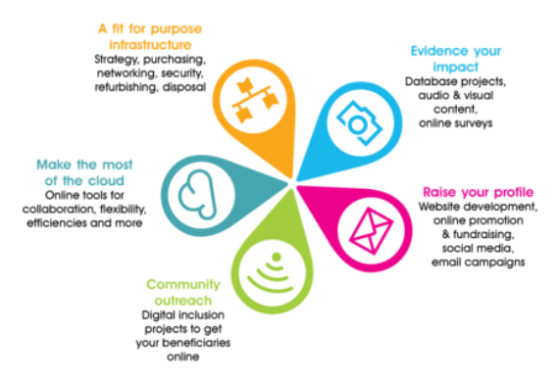
Figure 3: Graph Detailing Superhighway’s Services

Superhighways also runs a project called Impact Aloud that supports nonprofit organizations toward using technology to monitor, evaluate, and communicate their impact. Over a period of 2.5 years, Impact Aloud has supported 319 organizations. The Superhighways website (Our Impact, www.superhighways.org.uk) shares several stories from individuals and nonprofits who have benefited from the Impact Aloud initiative.

Evaluation
Conducting the Superhighways interview was expected to derive meaningful information due to the previous work they did regarding the Wimblecomm website. They submitted a report last year to the WCA which included several recommendations focused primarily on web site issues and secondarily on business plan development. The interviewee was Sorrel Parsons, who works as a Digital Advisor for the organization. When asked to state in her own words the mission statement of Superhighways, she stated that the main goal is to “harness the power of technology for communities” and “helping nonprofits become more efficient and develop tech skills” (Sorrel Parsons Interview, 2018). Regarding community need for the services offered by Superhighways, she replied that digital skills typically lack in lower income nonprofit organizations. The underlying questions that drive this lack for nonprofits are: What if I make a mistake with the investment in tech support? and What if it doesn’t work? Sorrel mentioned that she advises clients to never spend more than five thousand pounds, however it is all dependent on the type of services needed. It is common for clients to not have enough knowledge to articulate their needs accurately.
Regarding the steps Superhighways takes to achieve their vision, she referred to the Digital Inclusion projects, identifying how each client deals with technology, what prevents them from using technology to their advantage, offering training and one-to-one consultancy free and paid, and strategic networking. The determining factor of whether services are free or paid depend on what Superhighways has direct funding for. In general, the services they offer are low-cost, often charging much less than similar companies in England. Sorrel said that the helpdesk service is based on an annual membership. Superhighways do bring in several volunteers to help support that, mostly university students or people who are in transit between jobs. Given the skill set needed, she admitted that it is difficult to get people to offer IT services for free.
There is no marketing department of employee, but funding has allowed for opportunities to make connections. She did not specify further. The target market segment is more geographical than financial, with Superhighways offering their services to businesses that make less than 100,000 pounds a year and nonprofit organizations in the London area. Sorrel defined a small nonprofit as one worth less than 1.5 million pounds. Success for their organization would be for their service to be known and used by all applicable businesses and nonprofits in the London area. As technology constantly changes, so will the needs of the community regarding technology. Superhighways must continuously adapt to these changes to maintain relevancy and have the technical expertise to address those needs. They measure success by the number of people and organizations who make changes based on the recommendations presented by Superhighways.
When asked about the recommendations made from the report Superhighways presented to the WCA last year, she said that there are several key technical issues. One problem she mentioned was that the search return is located at the bottom of the main page. This is a serious user design problem that the WCA’s current web designer told them was impossible to fix. However, Sorrel reassured me that it was a rather straightforward issue to resolve and if the current web designer cannot fix it, it might be beneficial for the WCA to seek out someone who can. There is also too much “front-loading” of information. If it takes a whole page to perform one step, then there is a problem. She called it a “classic user design problem” which again suggests that the WCA should seek out new talent. She expressed concern for the Google Analytics data being captured as well. She questioned whether the attributes being tracked were relevant and accurate indicators of site performance. They also determined that the functionality and design of Wimblecomm should orient the user to the service it offers. There is some confusion with the noticeboard and guest blog being included in the site instead of the site dealing exclusively with venue hiring.
When asked for suggestions regarding how an arbitrary start up group could increase its awareness in the community, Sorrel stated to first do market research for the area of focus. Then attend the right networks, collaborate and establish connections with people and organizations that can assist with advancing the agenda. Identifying key resources and the methods by which to access them is also a priority. There is no point connecting people to places if the organization cannot articulate its value to users and providers. In the beginning stages, organizational goals are usually vague, and it is important to move beyond theory to the practical task of how to achieve the set goal.

Summary
Superhighways is an organization that understands the value of networking and generating business, whether for-profit or nonprofit. They have a solid understanding of the nonprofit community’s IT needs and how their services meet those needs. This interview allowed for important observations and insights to be made regarding what the WCA needs to do to move forward. Networking was recommended as an effective marketing strategy and Superhighways is willing to work with the WCA again to further assist them toward their goals.

Appendix G: Case Study – South Park Gardens

Introduction
South Park Gardens is a Victorian styled residential park located in Wimbledon, originally designed in 1899 and officially opened in 1901. Merton Council purchased the land from a private owner as part of a parcel of approximately 6 acres with 2.4 hectares set aside for what was called the “South Park Pleasure Grounds”. The “Gardens” were constructed with a cost of roughly £600 and designed in a Beaux Art style with serpentine pathways, circular features and various shrubs, trees and flowerbeds to add to the aesthetic feel of the area. In 1904 the Metropolitan Drinking Fountain and Cattle Trough Association presented a drinking fountain and horse trough to the council. The stone drinking fountain was installed in the center of the Gardens shortly after, being presented by Ellen Reardon to commemorate her father, mother, and sister.
Cast iron railings were used to section off the area as part of the initial construction of the site, but these were dismantled and removed to contribute to the war effort in the early 1940’s. For about a decade, the Gardens were left without any formal boundary. During the 1950’s a set of concrete pillars and chain link fence was erected. Unfortunately, the chain link fencing broke down regularly and allowed for security and maintenance issues related to the upkeeping of the Gardens. During the 1990’s the overall condition of the Gardens continued to decline, with increasing instances of vandalism, antisocial behavior and litter-dropping. In 2002 one of the three ornamental gates originally installed in 1994 was stolen. This occurrence led to a public meeting of concerned local residents and the eventual founding of the Friends of South Park Gardens.
As part of their founding principles, they resolved to restore the Gardens to its original aesthetic beauty. They lobbied Merton Council to make changes regarding the maintenance of the Gardens and to explore alternate funding options. Merton Council and Friends of South Park Gardens worked jointly on a feasibility analysis to gauge the plausibility of finding resources to move forward with improving the park. They applied for a grant to the Heritage Lottery Fund (HLF) and, after several years passed, a grant of approximately £1.4m was awarded.
With the newly allocated funds, the Friends organized a series of community events, one of which is expanding on the annual community picnic they host every year. Some of the events they currently organize include: Easter Egg Hunts, Picnics, Fireworks and Bonfire Events, Over 60s Cream Teas and Carol Singing. As part of their fundraising efforts, they have received over £50,000 which is being invested toward the continued maintenance, improvement and upkeeping of the Park. The Friends meet regularly among themselves and with the local community to give and receive feedback regarding issues of importance.
As part of the HLF project a small Garden Pavilion has been built in the Gardens that they use for hiring space out to the local community. The following guidelines from the South Park Gardens website (Garden Room for Hire, www.southparkgardens.com) show the rules for hiring out the space:
  - Parties (adult or children), music and amplified sound are NOT ALLOWED under the terms of the planning conditions. If you apply to request the room for a party, you may not receive a response.
  - The Garden Room is available for hire during park open hours
    - Until 5:50 pm from November to January;
    - Until 7:30 pm in February and March;
    - Until 8:00 pm between April and August;
    - Until 7:00 pm in September and October.
  - The Garden room can be partitioned in two. The maximum seated capacity of the half room is approximately 12 – 16. The maximum capacity of the whole space is 24 – 32. There is only limited availability to rent out the whole space.
  - The hourly rental rate for the half room is £10 pounds, the full room is £18. (Community activities for which there is no attendance fee are charged a nominal fee of £3 per hour to cover cleaning costs)
  - Payment is to be made by bank transfer, or by cheque, at the time the room is booked. A receipt will be sent by email.
  - There is a kiosk in the building run by commercial operators who can provide teas and coffee. If you would like to contact them for any catering needs, you might have to please ring Grant on 07757 557375.
  - You will need to leave the room clean, tidy and secure.
  - There is no on-site car parking.
  - A refund will be made on cancellation of a booking, subject to:
    - A 50% reduction if the booking is cancelled less than one week before the date of hire;
    - No refund will be given if the booking is cancelled less than two full days before the date of the booking

Evaluation
For the purposes of this interview, the interviewees were Jil Hall and Sylvia Lucas. When asked about the mission and overall purpose of the South Park Gardens, they stated it was to maintain, restore, and improve South Park Gardens with respect to the community. The actions they take to achieve those goal is broad, consisting generally of efforts to enhance the Gardens and improve them. They engage with the community through newsletters, hosting events, placing information on a noticeboard that is located within the Gardens, and their website (www.southparkgardens.org). Regarding membership they both stated that they do offer it, with 70 households signed up. Incentives for becoming a member include priority booking for certain events, such as the fireworks display. They mentioned that the membership is more about showing support to the Park rather than a value-added strategy.
Other than membership, Jil stated they try to run as many community events as possible, varying from bike runs (Guts in Motion) to arts festivals and Christmas carol events. When asked about the marketing strategies they use to bring awareness to the services they provide, Silvia mentioned their newsletter. It consists of a double sided A4 sheet and is sent to approximately 3000 households within a certain distance from the Gardens. The newsletter is also sent electronically to an established list of contacts and posted on their website. Local companies could take advantage of advertising the space to their employees to get away from the “office” and be closer to nature. Marketing the venue as a place to “get away” from the monotony of work is a useful strategy to reach out to the corporate world.

When asked what success means for the Garden Pavilion, Jil stated that it primarily consists of the pavilion being well-utilized, as well customer satisfaction with the space. Financially speaking, the goal is to break even rather than make any profit. They would like to offer the most affordable rates they can to encourage involvement with more disadvantaged groups. They plan to advertise the space to nonprofit organizations to ensure that their service is part of a greater welcoming environment for the community and to offer services that the community actually needs.

Summary

The South Park Gardens is a small park with an organic community structure. The Garden Pavilion they offer is also small in comparison to other organizations visited such as Polka Theatre and Trinity church. Nevertheless, they have an effective outreach strategy that works for them. The newsletter is hand delivered to every household with volunteers offering their time to perform the task. The Gardens themselves have meaning for the community which contributes greatly to any volunteer resources they obtain. The marketing tactics they use and the advice given regarding identifying up-and-coming nonprofits were the most valuable insights gained from the meeting.

Appendix H: Case Study – Love Wimbledon

Introduction
Love Wimbledon was established by local businesses in 2012 as a business improvement district (BID). A BID is defined as a business-led, not-for-profit company that represents, serves, and works to improve the designated area for business, visitors, and residents. It is a legal body formed by the Local Government Act of 2004. All BID levy paying businesses automatically become members and are recommended to attend Love Wimbledon’s project steering groups and board meetings. Love Wimbledon ensures accountability by measuring their performance by the following metrics (www.lovewimbledon.org):

- Yearly customer satisfaction and business surveys
- Financial savings to businesses
- Crime statistics
- Footfall statistics
- Social media followers and reach
- Website visits/media coverage
- E-card and newsletter open rates/click throughs
- Shop vacancy rates

Formal agreements are signed with Merton Council to ensure there is no overlapping between services offered by the council and those offered by Love Wimbledon. In 2015 Love Wimbledon received the British BIDs Accreditation which recognizes excellent management and financial practices, accountability and business engagement. According to their 2017 – 2022 BID Proposal, their promises include:

- To ensure Wimbledon Town Center is attractive, vibrant, and cared for
- To ensure the businesses, attractions and facilities of Wimbledon Town Center are connected, clearly presented and represented with a strong collective voice
- Services to businesses

They plan to accomplish these objectives by:

- Delivering engaging events and placemaking
  - Ensuring Wimbledon is an attractive, interesting and safe environment. A wide variety of different events and ensuring the town feels taken care of are priorities for many of our businesses.
- Developing leading marketing and promotion
  - Informing people about the great businesses here and the different things to do or see in Wimbledon is the key objective for our customer-facing businesses
- Providing inspiring business services and support
  - This program supports businesses with money saving services, practical support and facilitated business promotion and networking
- Ensuring a bright future for Wimbledon
  - Ensure Love Wimbledon gives town center businesses a strong voice in matters of strategic importance to the area.

The Proposal further describes in detail the actions they will take regarding their promises and objectives if voted in for another 5 years. In general, Love Wimbledon acts on behalf of their stakeholders and the results are intended to benefit the Wimbledon community.

Evaluation
The interview was held at the Love Wimbledon Main office and the interviewee was their Strategic Marketing Adviser, Sally Warren. She described Love Wimbledon’s mission and purpose was to be the voice and communicators of businesses in Wimbledon. They based their organization on an American business model originally set up to invest in underdeveloped communities. Because local councils have less money, local businesses run the organization and Love Wimbledon works on behalf of the businesses. Their target market includes business owners, people who work and could potentially do business in Wimbledon.
Regarding marketing strategies for nonprofits to use to increase awareness, Sally stated that the first question an organization must ask is: “What is the product?”. She offered the Alexandra Pub as an example. During the weekends, it tends to attract a large crowd of younger people and they generally fare well business-wise. During weekdays they open their space for elderly citizens meet ups. On Christmas Day, they provide free meals. They make a good balance of delivering their primary service to their customer but also making efforts toward social responsibility. The relationship between the private sector and charity is key. Sally also mentioned Wimbledon Guild and YMCA as two other examples.
With respect to Wimblecomm in particular, she recommended that working with an organization like Polka would be a good move for the WCA. Networking should be a top priority and it would be beneficial for the WCA to pursue partnerships. She said that Love Wimbledon would be interested in pushing clientele toward Wimblecomm if there were several improvements made to the site. The photography on the site does not promote the venues and the website is somewhat difficult to navigate. Sally also stated that the Wimblecomm venture should be distinct from the WCA as an organization.

Summary

Love Wimbledon has a strong record of success, a solid business plan, and effective marketing tactics. Sally provided two well designed brochures that clearly identify their goals, objectives, and means of achieving them. The private investment from companies along with the corporate responsibility concept demonstrates the value of working with commercial establishments. Her insight regarding Wimblecomm shared points with what Sorrel described in the Superhighways report. Although brief, the interview highlighted and revealed several issues that are common among the organizations evaluated thus far.

Appendix I: Case Study – The Merton Voluntary Service Council

Introduction
The MVSC is an organization that strives to support the voluntary, community, and faith sector in Merton. They network with other organizations such as the London Borough of Merton, Merton Chamber of Commerce, Merton Partnership, police, and fire services. According to their website (www.mvsc.co.uk) their vision is to establish a “thriving Merton community where people’s lives are enriched by voluntary and community action. The MVSC’s mission is “to inspire and develop an excellent voluntary and community sector in Merton”. Their website outlines their objectives and services as:
- Support to voluntary, community, faith and social enterprise organisations
  - Capacity and capability building
  - Training programme
  - Financial management and systems
  - Good governance and trustee support
  - Helping organisations with fundraising plans and applications
  - Merton Means Business.
- Encourage, support and develop volunteering and voluntary and community action
  - Enhance the recruitment, promotion and management of volunteers in Merton
  - Raise awareness of volunteering, gain recognition for the contribution of volunteers and highlight issues affecting volunteers
  - Deliver good practice support for organisations involving volunteers in their work
  - Provide information and advice about volunteering
  - Training for organisations and volunteers
  - Youth, Public Service and Supported Volunteering.
- Identify changing and emerging need and respond with development
  - Identify changing and emerging social and community needs and work with communities, the sector and public and private agencies to address them.
- Promote, support and develop liaison, advocacy, joint working and strategic partnership
  - Healthwatch Merton, the consumer champion for health and social care in Merton
  - Continue leading, facilitating and developing the voluntary sector’s roles in strategic partnerships and strengthening the sector’s voice, representation and influence with the public sector and funders, in Merton and externally
  - Play a key role in bringing together VCS organisations to strengthen collaborative working and partnerships; supporting joint working between sectors and accessing new funding
  - Seek to enhance co-production with the public sector and apply the Social Value Act in public sector commissioning.
- Promote quality through standard setting
  - Set and raise standards in the voluntary and community sector by promoting organizational quality assurance systems and volunteer management quality standards.
- Sustainability
  - Undertake sound planning to continue MVSC’s work supporting Merton’s VCS
  - Support the sector’s sustainability through diversification of its income streams.
They are committed advocates of volunteering and network with local organizations to connect volunteers and their skill sets with appropriate opportunities. Several projects the MVSC orchestrates include Health Champions, Merton Befriending Service, Merton Connected, Merton Means Business, and Modern Day Centres.

Evaluation
The interviewee for MVSC was Beau Fadahunsi, Head of Development and Volunteering. She identified the mission of the MVSC as to see a thriving Merton community in which residents and citizens lives are enriched. To clarify. To accomplish that goal, she stated they offer development and capacity building support to civil society organizations (charities, voluntary sector, social enterprises, etc.). They facilitate forums and networking for local VCF civil society organizations. Also, the MVSC acts as a voice for the advocacy of statutory services and policy makers including councilors and politicians, brokering support for volunteering and community action. Regarding corporate structure, Beau replied that the MVSC is a charity company limited by guarantee. They have a constitution that functions as their leading governing document as well as business plans, a mission statement and set of core values and ethics. There is a board of trustees who are legally responsible for the organization (9 members) and all representatives of local charity organizations. The MVSC is well developed with this aspect of their organization.
They offer memberships, but it is not required to be a member to receive a service. Their membership numbers currently stand at 600 and membership is free of charge. However, they are considering going into a paid membership with enhanced support to generate revenue. Several membership benefits include access to community accountant service for small organizations who do not have a bookkeeper. Beau stated that the MVSC functions as the umbrella organization and communication “middleman” for the borough. They disseminate an e-bulletin and facilitate conferences with VCF organizations and residents. They engage in campaigns, major sporting events, publicize other organizations activities and assist with the drafting of business documents.
When asked about their target market and marketing strategies, she said their market is twofold: residents and employees within Merton who would volunteer. Basically, local civil society organizations and residents who could be recipients of civil society services. They are active on social media (facebook, twitter, etc.) and create leaflets, posters, videos, perform community outreach and promote their website. The MVSC is seen in the community as a resource in itself and they provide money to individuals and organizations in the form of grants depending on the need and whether the applicant qualifies for the grant. These effective actions keep the MVSC connected to the Merton community it serves and maintains interest in what they do. It is important to mention that the services offered are actual needs the community has, which is the primary reason why the organization functions so well.
The interview was cut short due to the limited time the interviewee had.

Summary

The MVSC is an organization that is well developed business-wise and marketing-wise. They understand the importance of having a clear mission, set of objectives and plan to accomplish those objectives. They work with the nonprofit sector but have access to funds which allows them to play the role of “investor” with respect to the grants they offer. Due to their position as an organization that helps other organizations, the MVSC itself functions as a resource for an up-and-coming nonprofit who seeks to get established in the community. Although the interview was cut short, the outreach strategies mentioned above and the detailed business plan and structure shown on their website are examples for any organization trying to formalize their venture.

Appendix J: My Community Space

Introduction
My Community Space is a charity that presents approximately 1000 meeting rooms, offices, halls, and other venues for use by the voluntary sector or their local community. They have a website (www.mycommunityspace.com) which functions as an online forum for venue providers to advertise their space and venue users to search and select the venue of their choice. They are open to private or commercial organizations only if they offer their space(s) free of charge or at a significant discount. According to their website, My Community Space is for “any charity, nonprofit, or community group” who are:
- Looking for a space to base your activities or hold an event – whether it is desk space, meeting room, hall, studio or other venue for an hour, a day, week, month or year
- Wanting to let others know about the Space2Share you have available and earn some extra income
The website was created in 2009 by an organization called “Community Matters” which is now closed. They represented a large network of community organizations in the UK with over 1200 members. They routinely host exhibitions at various locations throughout the UK, where they showcase their accomplishments on the local, regional, and national level.

Evaluation
The interviewee’s name was George Cook, Inventor and Director for My Community Space. When asked to state in his own words the mission and purpose of his organization, he replied it is to provide every village hall and community center in the nation with its own website and booking system. He wants to launch a fully online booking platform for a fully automated personal site and booking system for community centers. George also is focused on encouraging business to volunteer their employees or assets for charity. The actions taken to achieve those goals include consulting with charities using the site to look for rooms and conduct surveys. The most important objective was money or being able to afford a lower salary. He stated that he has relationships with several property companies and that one of them will be acquiring roughly 400 office buildings. They will allow My Community Space to utilize the rooms free of charge.
Regarding corporate structure and organizational model, he did not provide much information. George stated that he takes things one step at time and does not necessary plan out too much into the future with respect to organizational aims. He did mention that they have a “mem of articles” and the wider organization (beyond My Community Space) has an organizational hierarchy that consists of himself, chief executive, and 50 – 60 employed staff. He did mention in detail the roles of the staff members. Marketing is conducted primarily by voluntary exhibitions, social media, and creating relationships. They do not advertise and have no brochures or George spoke in vague terms throughout the interview and did not go into too much detail. He mentioned that he operates like the “Wombles” and that “things just happen”.
Regarding what success meant for his organization, he stated that he would like to have all 22,000 village halls and 20 charity centers in the nation registered, an ambitious goal. He mentioned that he would like to work with the WCA regarding Wimblecomm, which was a positive sign. For a nonprofit trying to increase the presence in their community, he advised working with private companies and stressed the importance of networking.

Summary
George Cook is a successful former business man who was able to forge many relationships during his entrepreneurial career. My Community Space is unique in the sense that it is run by someone with the wealth and contacts needed to continue innovating and capitalizing on new opportunities. In that sense, My Community Space in very different from Wimblecomm. However, he strongly advocated networking and forging relationships with commercial organizations. This opinion has been expressed during several interviews previously conducted. George was eccentric, and it made for good conversation, but his vagueness regarding several important topics such as marketing and organizational structure left little meaningful information to be gained for the purposes of this project.

Appendix K: Trustee Meeting

On 21 May 2018, David Hall organized a meeting with the following trustees: Roger Drage, Bill Lake, and Jackie Chapman. As part of the meeting, each of the trustees were interviewed individually for approximately 30 minutes to gain insight regarding the WCA as an organization and Wimblecomm as a venture.

Roger Drage
The first question posed to Roger concerned his personal view of the future of the WCA. He stated that he saw the WCA as being a major contributor to the Merton borough, that the main problem is that disparate groups in the borough are separate. His view was that the WCA should seriously consider acquiring another property. Diverse groups would meet there individually, but that would increase the “community feel” with respect to the physical location. The long-term aim is to build a community service that will bring the community together. When asked whether the WCA has done a good job marketing the Wimblecomm venture, he replied that extensive marketing efforts were being made to build the service which would in his view show positive results in due course.
Although the WCA has some money stemming from the sale of their original building, they have not invested too much from it. The lack of volunteers was a topic of concern for him as well as adequate tech support, referring to the Superhighways report findings. Roger strongly supports the hiring of the temporary marketing support, Genevieve and wants to see more volunteers and trustees working for the organization. He believes that not enough capital and resources have been invested into the success of the Wimblecomm venture, and if Wimblecomm is not successful then another venture should be considered.
Regarding mergers, Roger thought that it would be fine if it was beneficial for the WCA but did not want to merge with Polka Theatre. His personal time commitment to the Wimblecomm venture is 1 day per week and acknowledged that may not be enough, which is why he believes more trustees and volunteers are needed. The WCA as an organization should be providing added value to the Merton community, not just for room letting. He strongly advocated for the WCA to host community events to bring the community together.
Bill Lake
When asked where the WCA should be 5 years from now, Bill stated that it should be moving toward helping the community with a huge amount of activities going on. He wanted businesses and people of all ages engaging with the WCA as a community resource. Regarding communication with the community and venue providers, he believes that it has been poor, and more emphasis should be placed on effective marketing. He agreed with Roger that hiring Genevieve was a good idea, but more volunteers would be needed to further the Wimblecomm venture. Bill stated that a proper business plan was needed and that not too much “financial work” has been done to date with respect to Wimblecomm or the WCA.

Jackie Chapman
The interview was started with the similar question of where the WCA should be in 5 years. Jackie felt that the WCA should function as a community relations hub and questioned whether the WCA has been successful “tapping into the community spirit”. Regarding communication and marketing, she stated that the WCA may not have been focused enough on communicating with venue providers or users – building the website had taken a lot of time. They are currently struggling trying to capture the essence of the community relations. She reiterated similar points to what Roger and Bill said about the lack of volunteers and the need to attract more trustees. More volunteers are needed perhaps, to “man” the social media and build up the WCA’s and Wimblecomm’s online presence and to support our networking efforts. She mentioned that they have not adequately articulated the value and mission of their organization to the people. The aims of the organization and website must be made clear.
She spoke briefly about the surveys they conducted last year and how the results also gave evidence to the fact that they are not effectively engaging with venue providers or users. When asked if she would be willing to partner with another organization to move the WCA forward, she said yes.

Appendix L: Web Designer Meeting
The primary purpose for this meeting was to spend some time discussing the results of the Superhighways report. The web designer’s name is Tim. This meeting included David Hall, Susanne Ollig, Bill Lake, and Roger Drage. David mentioned the Superhighways report and wanted Tim to clarify exactly how he plans to address the findings. Roger explained to Tim that he is primarily interested in the interface between Tim, Susanne, and the Superhighways report. Susanne mentioned search engine issues identified by Superhighways and expressed several concerns regarding the overall them of the site. Based on the interview conducted with Sorrel from Superhighways, she said that these issues can be resolved in a relative short period of time.
Tim responded stating that he is planning to “take a look” at restructuring the page and simplification of the website. David mentioned the lack of effective filter options and the home screen menu not being intuitive. Tim replied that he could make the search text field prominent and that he could accomplish that task in a couple of weeks. He suggested that a complete revamp of the website might be the best idea. Roger asked Tim what the timescale for him is to come up with a plan to revamp the site and address the Superhighways report findings, Tim replied 2 months.

Appendix M: Survey Results

Prospective Venue Provider Survey

Q2 - Are you familiar with a community venue directory site called Wimblecomm?
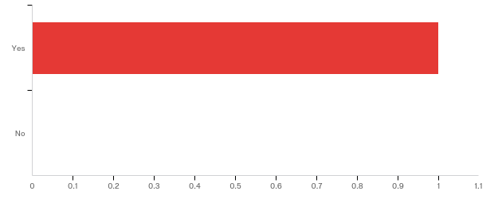

# | Answer | % | Count
1 | Yes | 100.00% | 1
2 | No | 0.00% | 0
 | Total | 100% | 1

Q3 - How did you become aware of Wimblecomm?
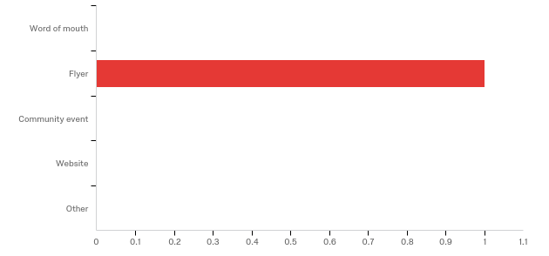

# | Answer | % | Count
1 | Word of mouth | 0.00% | 0
2 | Flyer | 100.00% | 1
3 | Community event | 0.00% | 0
4 | Website | 0.00% | 0
5 | Other | 0.00% | 0
 | Total | 100% | 1

Other
Other - Text

Q4 - Do you advertise your venue through any other websites?

# | Answer | % | Count
1 | Yes | 100.00% | 1
2 | No | 0.00% | 0
 | Total | 100% | 1

Q5 - What has prevented you from utilizing Wimblecomm’s site to advertise your space?
What has prevented you from utilizing Wimblecomm’s site to advertise your space?

Q6 - Please provide the name(s) of the site(s) where you are currently advertising your venue.
Please provide the name(s) of the site(s) where you are currently advertising your venue.

Q7 - Are you interested in advertising your space for hire?

# | Answer | % | Count
1 | Yes | 0.00% | 0
2 | No | 0.00% | 0
 | Total | 100% | 0

Q8 - Are you currently experiencing financial strain due to a lack of public funding?

# | Answer | % | Count
1 | Yes | 0.00% | 0
2 | No | 0.00% | 0
 | Total | 100% | 0

Q9 - If you could supplement your income by advertising your space for hire, would you do it?

# | Answer | % | Count
1 | Yes | 0.00% | 0
2 | No | 0.00% | 0
 | Total | 100% | 0

Q10 - Are you aware of the potential benefits of advertising your space through Wimblecomm?

# | Answer | % | Count
1 | Yes | 0.00% | 0
2 | No | 0.00% | 0
 | Total | 100% | 0

Q11 - What forms of social media do you interact with regularly? (Select all that apply)

# | Answer | % | Count
1 | Facebook | 0.00% | 0
2 | Instagram | 0.00% | 0
3 | Snapchat | 0.00% | 0
4 | Twitter | 0.00% | 0
 | Total | 100% | 0

Q12 - If an organization wanted to have your attention, which of the following forms of communication would be most effective?

# | Answer | % | Count
1 | E-mail | 0.00% | 0
2 | Social Media | 0.00% | 0
3 | Regular mail (flyer, brochure, etc.) | 0.00% | 0
4 | Telephone call | 0.00% | 0
5 | Other | 0.00% | 0
 | Total | 100% | 0

Other
Other – Text

Q13 - If Wimblecomm organized a community networking event, would you attend?

# | Answer | % | Count
1 | Yes | 0.00% | 0
2 | No | 0.00% | 0
 | Total | 100% | 0

Current Venue Provider Survey

Q3 - How did you initially become aware of Wimblecomm?
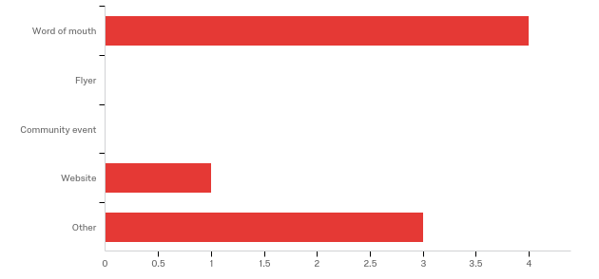

# | Answer | % | Count
1 | Word of mouth | 50.00% | 4
2 | Flyer | 0.00% | 0
3 | Community event | 0.00% | 0
4 | Website | 12.50% | 1
5 | Other | 37.50% | 3
 | Total | 100% | 8

Other
Other - Text
Via Work
an email direct to us
community centre

Q4 - How long have you been a registered member of Wimblecomm?
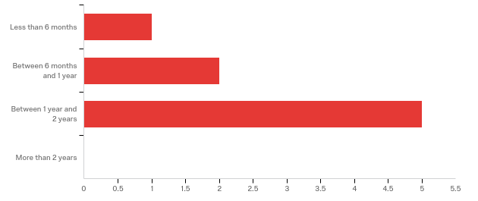

# | Answer | % | Count
1 | Less than 6 months | 12.50% | 1
2 | Between 6 months and 1 year | 25.00% | 2
3 | Between 1 year and 2 years | 62.50% | 5
4 | More than 2 years | 0.00% | 0
 | Total | 100% | 8

Q6 - Have you secured venue rentals by people who found your venue through Wimblecomm?
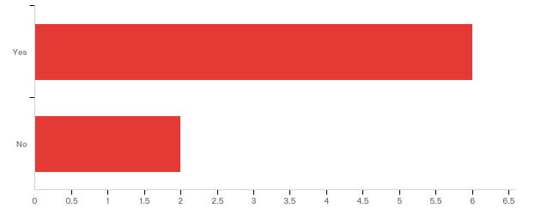

# | Answer | % | Count
1 | Yes | 75.00% | 6
2 | No | 25.00% | 2
 | Total | 100% | 8

Q7 - Could you estimate how many times given a time frame of your choice (e.g. 5 times a month)?

Just one every now and again
Do not understand question
once per 2 months?
Twice in 6-months
3 a month
2 time a year

Q8 - Is your venue space advertised on other community venue directory sites?
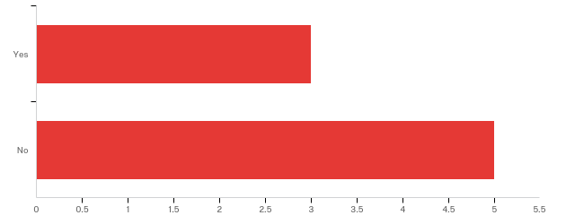

# | Answer | % | Count
1 | Yes | 37.50% | 3
2 | No | 62.50% | 5
 | Total | 100% | 8

Q9 - Please provide the name(s) of the sites?

Merton Council
MVSC; SMCA
ghtekekowk

Q10 - The number of venue rentals you secure through the sites you mentioned compared to Wimblecomm are:
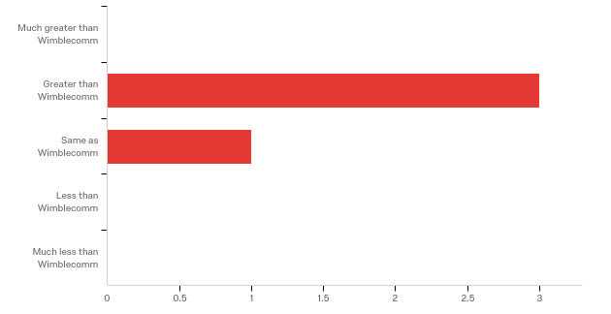

# | Answer | % | Count
1 | Much greater than Wimblecomm | 0.00% | 0
2 | Greater than Wimblecomm | 75.00% | 3
3 | Same as Wimblecomm | 25.00% | 1
4 | Less than Wimblecomm | 0.00% | 0
5 | Much less than Wimblecomm | 0.00% | 0
 | Total | 100% | 4

Q11 - In your opinion, what are the reasons to account for this difference (or sameness)?

we only registered with Wimblecomm last week!
Established longer

Q12 - Do you believe that Wimblecomm provides a vital service to the greater Merton community?
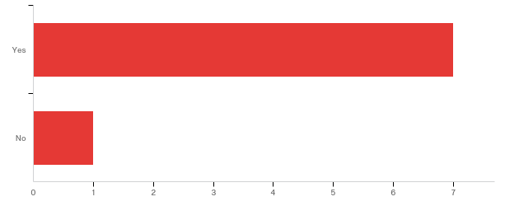

# | Answer | % | Count
1 | Yes | 87.50% | 7
2 | No | 12.50% | 1
 | Total | 100% | 8

Q13 - Please explain in more detail.
Please explain in more detail.

Q14 - What features/services would you like to see Wimblecomm offer you as a current member?

just the venue listing - it's all we need at the moment.

Q15 - If Wimblecomm organized a community networking event, would you attend?
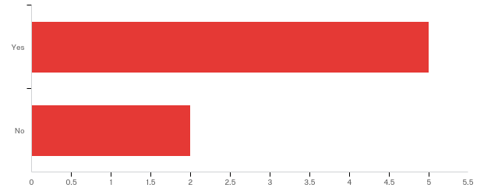

# | Answer | % | Count
1 | Yes | 71.43% | 5
2 | No | 28.57% | 2
 | Total | 100% | 7

Q16 - Please explain why you prefer not to attend.

too busy . We have no paid staff and everything falls to volunteers.
not relevant to our organisation

Q17 - Do you know the names of any board members of Wimblecomm?
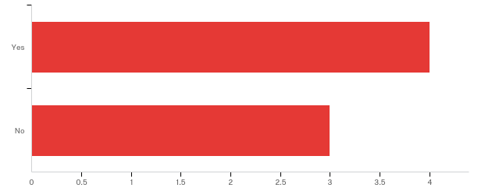

# | Answer | % | Count
1 | Yes | 57.14% | 4
2 | No | 42.86% | 3
 | Total | 100% | 7

Q18 - Please provide the names.

David Hall, Roger Drage
Roger Drage, David Hall etc.
David Hall, Jackie, Roger Drage, Bill

Q19 - What do you like about the services Wimblecomm provides to you as a member?

Firstly the relationship, secondly, knowing we have local support to get the word out about our premises is extremely valued
easy to use.
It is a free listing
Extra bookings and a way to advertise events

Q20 - What do you dislike about the services Wimblecomm provides to you as a member?

N/A

Q21 - In what areas do you think Wimblecomm can improve regarding its service?

Nothing comes to mind right now
advertise the website more e.g. on social media, noticeboards, local mags/newspaper etc.

General Public Survey

Q2 - Have you used Wimblecomm to search for a venue before?
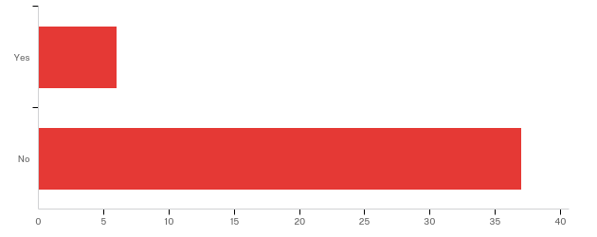

# | Answer | % | Count
1 | Yes | 13.95% | 6
2 | No | 86.05% | 37
 | Total | 100% | 43

Q3 - How did you become aware of Wimblecomm?
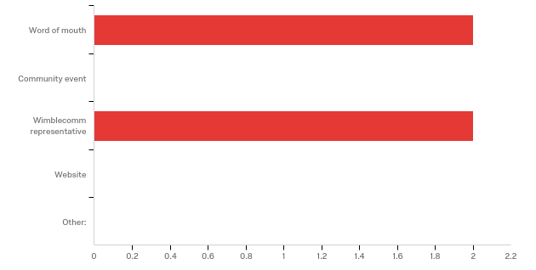

# | Answer | % | Count
1 | Word of mouth | 50.00% | 2
2 | Community event | 0.00% | 0
3 | Wimblecomm representative | 50.00% | 2
4 | Website | 0.00% | 0
5 | Other: | 0.00% | 0
 | Total | 100% | 4

Other:
Other: - Text

Q4 - Does Wimblecomm present the type of venue(s) you are looking for?
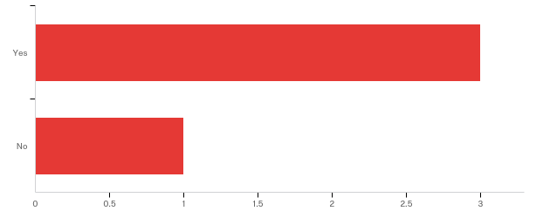

# | Answer | % | Count
1 | Yes | 75.00% | 3
2 | No | 25.00% | 1
 | Total | 100% | 4

Q5 - What type of venue(s) are missing from the Wimblecomm site that you would like to see?

hffhfhfh

Q6 - When in need of a venue, is Wimblecomm the first place that you search?
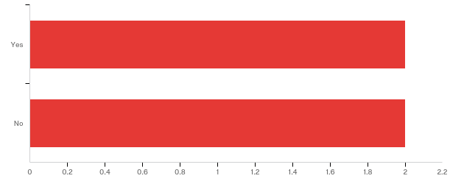

# | Answer | % | Count
1 | Yes | 50.00% | 2
2 | No | 50.00% | 2
 | Total | 100% | 4

Q7 - What other community venue directory sites do you visit?

SW19 mums or word of mouth

Q8 - Are you satisfied with the service provided to you by Wimblecomm?
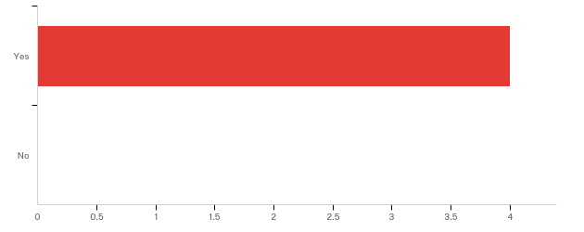

# | Answer | % | Count
1 | Yes | 100.00% | 4
2 | No | 0.00% | 0
 | Total | 100% | 4

Q9 - Please explain how Wimblecomm's service satisfies you.

good choice of venues
Has all the details in one place

Q10 - Please explain why you are not satisfied.
Please explain why you are not satisfied.

Q11 - Are there other venue-related services that you would like Wimblecomm to add to the website?

# | Answer | % | Count
1 | Yes | 50.00% | 2
2 | No | 50.00% | 2
 | Total | 100% | 4

Q12 - Please describe the added-services you are looking for.

Every quirky venue, pub, sports hall etc
Some more commercial bookings too

Q13 - If an organization wanted to have your attention, which of the following forms of communication would be most effective?
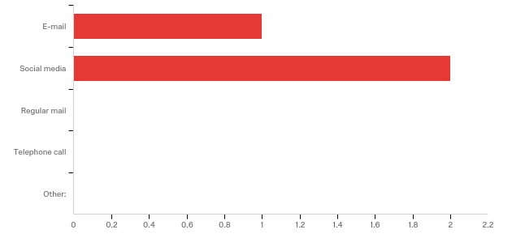

# | Answer | % | Count
1 | E-mail | 33.33% | 1
2 | Social media | 66.67% | 2
3 | Regular mail | 0.00% | 0
4 | Telephone call | 0.00% | 0
5 | Other: | 0.00% | 0
 | Total | 100% | 3

Other:
Other: - Text

Q14 - If Wimblecomm organized a community networking event, would you attend?

# | Answer | % | Count
1 | Yes | 75.00% | 3
2 | No | 25.00% | 1
 | Total | 100% | 4

Q15 - Please explain why you would not attend.
Please explain why you would not attend.

Q16 - How often are you in need of hiring a venue?
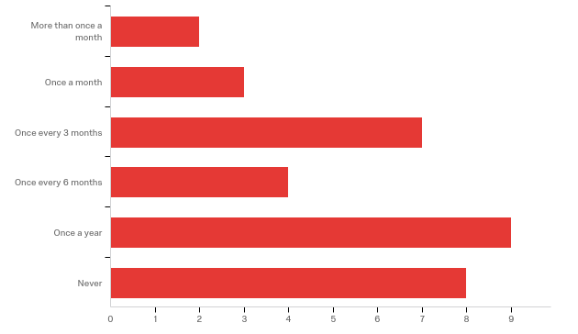

# | Answer | % | Count
1 | More than once a month | 6.06% | 2
2 | Once a month | 9.09% | 3
3 | Once every 3 months | 21.21% | 7
4 | Once every 6 months | 12.12% | 4
5 | Once a year | 27.27% | 9
6 | Never | 24.24% | 8
 | Total | 100% | 33

Q17 - Are you familiar with a community venue directory site called Wimblecomm?
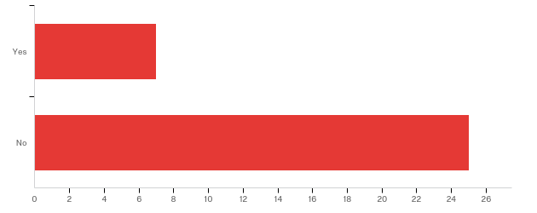

# | Answer | % | Count
1 | Yes | 21.88% | 7
2 | No | 78.13% | 25
 | Total | 100% | 32

Q18 - How did you become aware of Wimblecomm?
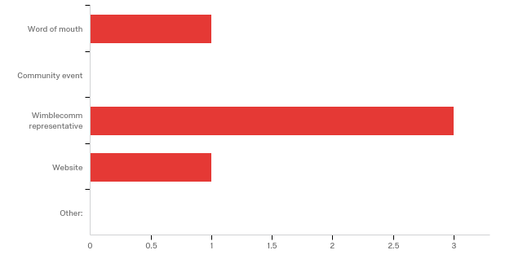

# | Answer | % | Count
1 | Word of mouth | 20.00% | 1
2 | Community event | 0.00% | 0
3 | Wimblecomm representative | 60.00% | 3
4 | Website | 20.00% | 1
5 | Other: | 0.00% | 0
 | Total | 100% | 5

Other:
Other: - Text

Q19 - When you are looking for a venue, what other resources (websites) do you use?

Don't use any. Try to think of venues and then search for them and contact directly.
Facebook
Search engine google
Would normally ask for recommendations via facebook groups/ local friends
None
A club of which I am a member
Google
Website, personal recommendation
Merton Council, my own list of venues
google
Google, Hallshire
Merton Partnership contacts, google, merton.gov.uk site
Word of mouth -google and Wimbledon Indians facebook page
http://rehearsalspacefinder.com/
Talking to community partners I know have spaces
Google
personal networks
Google search
Local knowledge & google search
Merton Council website. Map of the borough.
xxx

Q20 - What forms of social media do you interact with regularly? (Select all that apply)
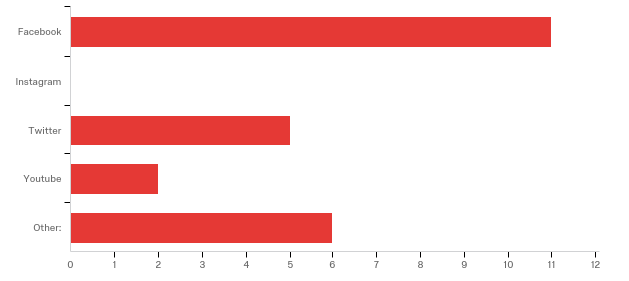
Other:
Other: - Text
Google
NEXT DOOR
Next Door
Whatsapp
YOUR FORM ONLY ALLOWS ONE. ALL APPLY
linked in & twitter

# | Answer | % | Count
1 | Facebook | 45.83% | 11
2 | Instagram | 0.00% | 0
3 | Twitter | 20.83% | 5
4 | Youtube | 8.33% | 2
5 | Other: | 25.00% | 6
 | Total | 100% | 24

Q21 - If an organization wanted to have your attention, which of the following forms of communication would be most effective?
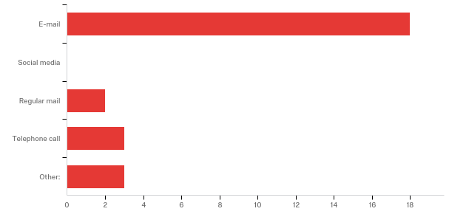

# | Answer | % | Count
1 | E-mail | 69.23% | 18
2 | Social media | 0.00% | 0
3 | Regular mail | 7.69% | 2
4 | Telephone call | 11.54% | 3
5 | Other: | 11.54% | 3
 | Total | 100% | 26

Other:
Other: - Text
Personal visits
depends on the context
all of the above

Q22 - If Wimblecomm organized a community networking event, would you attend?
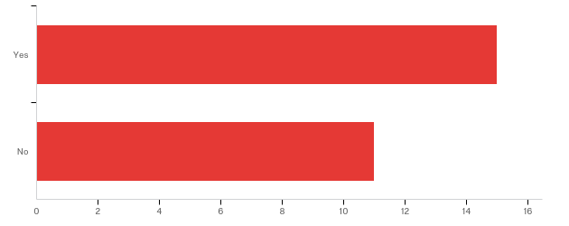

# | Answer | % | Count
1 | Yes | 57.69% | 15
2 | No | 42.31% | 11
 | Total | 100% | 26

Q23 - Please explain why you would not attend?
Not sure what the purpose would be.
I think I know enough venues
Old and disabled.
Not sure the relevance to me
Due to lack of time
No gurantee of £ being generated from networking. Limited resources
I'm afraid the questionnaire doesn't explain fully who wimblecomm are, or what the networking event is, so in this instance, with this little info, I don't think I'd attend a networking event.
Time restraints

Appendix N: Interview Script

- Opening
My name is Daniel Luis Soltren. I am a student at Worcester Polytechnic Institute and am conducting research on behalf of the Wimbledon Community Association. We would like to ask you several questions regarding your organization, its business model and marketing strategies. Our goal is to use this information toward identifying ways for Wimblecomm to continue its development as an organization and increase awareness of the service it offers in the greater Merton community. As stated in the interview consent form, this interview will take approximately 45 – 60 minutes. Are you ready to answer some questions at this time?

- Body

  - For the record, please state your name and position at (organization name).
  - In your words, what is (organization name)’s mission/purpose?
    - Could you explain in detail the actions your organization takes to accomplish its mission?
  - What type of corporate structure is (organization name) modeled after?
    - How did the founders of (organization name) determine which organizational model was most appropriate?
  - Does (organization name) offer memberships?
    - How many members do you currently have?
    - Are there benefits for becoming a member?
      - If so, what are they?
  - What incentives, other than membership, does (organization name) offer to individuals and organizations to encourage involvement?
  - How would you describe your target market segment?
    - What marketing strategies does (organization name) use to bring community awareness regarding its service(s)?
    - How does (organization name) attract and maintain community interest in its service(s)?
  - What struggles did (organization name) face during its initial development stages?
  - What does “success” mean for (organization name)?
    - Is success related to measurable goals?
      - If so, what are they?
      - How do you measure them?
  - In your opinion, what should be the main priority for an organization looking to increase its presence in the community?
    - How would you suggest they proceed?
      - What steps should they take to achieve that objective?

- Closing
We appreciate your time and insight you were able to provide us regarding your organization. Is there anything else you would like to add before we close this interview?
- If yes, allow for interviewee to share. Pursue additional questioning as necessary. Close the interview when finished.
If no, thank the interviewee and proceed with closing the interview.

Appendix O: Survey Questions (Current Venue Providers)

Preamble
Thank you for agreeing to complete this survey! The purpose of this survey is to gain information regarding your experience with venue hiring services such as Wimblecomm. This survey should take approximately 5 minutes to complete. Please be assured of the following:
- The results of this survey will be kept confidential and will not be attributed to you in any way;
- Any personal information will not be included in the results of this survey;
- You are free to skip any questions you do not wish to answer;
- Participants are free to end their participation at any time
- Any answers you provide will be shared only with the research investigators and kept in the strictest confidentiality.
Click on the arrow to begin (survey disseminated through Qualtrics).

Questions
- How did you initially become aware of Wimblecomm?
  - Word of mouth
  - Flyer
  - Website
  - Third-party venue hiring service
- How long have you been a registered member of Wimblecomm?
  - Less than 6 months
  - Between 6 months and 1 year
  - Between 1 year and 2 years
  - More than 2 years
- Have you secured venue rentals by people who found your venue through Wimblecomm?
  - Yes
  - No
- If yes, could you estimate how many times given a time frame of your choice (i.e. 5 times a month, etc.)?
  - Text field
- Is your venue space advertised on other venue-hire websites?
  - Yes
  - No
- If yes, please provide names.
  - Text field
- Are the number of venue rentals you secure through the sites you mentioned compared to Wimblecomm are:
  - Much greater than Wimblecomm
  - Greater than Wimblecomm
  - Same as Wimblecomm
  - Lesser than Wimblecomm
  - Much lesser than Wimblecomm
- In your opinion, what are the determining factors that account for this difference?
  - Text field
- Do you feel that Wimblecomm provides a vital service to the greater Merton community?
  - Yes
  - No
- If no, please explain in more detail.
  - Text field
- What features/services would you like to see Wimblecomm offer you as a current member?
  - Text field
- If Wimblecomm organized a community event, would you attend?
  - Yes
  - No
- If yes, please explain under what circumstances.
  - Text field
- If no, please explain why you prefer not to attend.
  - Text field
- Do you know the names of any of the board members of Wimblecomm?
  - Yes
  - No
- If yes, please provide names.
  - Text field
- What do you like about the services Wimblecomm provides to you as a member?
  - Text field
- What do you dislike about the services Wimblecomm provides to you as a member?
  - Text field
- In what areas do you think Wimblecomm can improve regarding its service?
  - A text field

Closing
Thank you for completing this survey!

Appendix P: Survey Questions (Prospective Venue Providers)

Preamble
Thank you for agreeing to complete this survey! The purpose of this survey is to gain information regarding your experience with venue hiring services. This survey should take approximately 5 minutes to complete. Please be assured of the following:
- The results of this survey will be kept confidential and will not be attributed to you in any way;
- Any personal information will not be included in the results of this survey;
- You are free to skip any questions you do not wish to answer;
- Participants are free to end their participation at any time
- Any answers you provide will be shared only with the research investigators and kept in the strictest confidentiality.
Click on the arrow to begin (survey disseminated through Qualtrics).

Questions
- Are you familiar with an online venue-hiring website called Wimblecomm?
  - Yes
  - No
    - If yes, how did you become aware of Wimblecomm?
      - Word of mouth
      - Flyer
      - Community event
      - Website
      - Other
- Do you advertise your venue through any other websites?
  - Yes
  - No
    - If yes, what has prevented you from utilizing Wimblecomm’s site to advertise your space?
      - (Text field)
    - If yes, lease provide the name(s) of the site(s) where you are currently advertising your venue.
      - (Text field)
    - If no, are you interested in advertising your space for hire?
      - Yes
      - No
- Are you currently experiencing financial strain due to a lack of public funding?
  - Yes
  - No
- If you could supplement your income by advertising your space for hire, would you do it?
  - Yes
  - No
- Are you aware of the potential benefits of advertising your space through Wimblecomm?
  - Yes
  - No
- What forms of social media do you interact with regularly? (Select all that apply)
  - Facebook
  - Instagram
  - Snapchat
  - Twitter
- If Wimblecomm wanted to have your attention, which of the following forms of communication would be most effective?
  - E-mail
  - Social media (Facebook, Twitter, etc.)
  - Regular mail (Flyer, brochure, etc.)
  - Telephone call
  - Other (text field)

- If Wimblecomm organized a community networking event, would you attend?
  - Yes
  - No

Closing
Thank you for completing this survey!

Appendix Q: Survey Questions (Current Venue Users)

Preamble
Thank you for agreeing to complete this survey! The purpose of this survey is to gain information regarding your experience with venue hiring services such as Wimblecomm. This survey should take approximately 5 minutes to complete. Please be assured of the following:
- The results of this survey will be kept confidential and will not be attributed to you in any way;
- Any personal information will not be included in the results of this survey;
- You are free to skip any questions you do not wish to answer;
- Participants are free to end their participation at any time;
- Any answers you provide will be shared only with the research investigators and kept in the strictest confidentiality.
Click on the arrow to begin (survey disseminated through Qualtrics).

Questions
- How did you become aware of Wimblecomm?
  - Word of mouth
  - Community event
  - Representative of Wimblecomm
  - Website
  - Other (Text field)
- Does Wimblecomm present the type of venue(s) you are looking for?
  - Yes
  - No
    - If no, what type of venue(s) are missing from the Wimblecomm site that you would like to see?
      - (Text field)
- When in need of a venue, is Wimblecomm the first place you search?
  - Yes
  - No
    - If no, what other online venue hiring service organizations do you visit?
      - (Text field)
- Are you satisfied with your membership with Wimblecomm?
  - Yes
  - No
    - If yes, please explain how Wimblecomm satisfies you.
      - (Text field)
    - If no, please explain why you are not satisfied.
      - (Text field)
- Are there other venue-related services that you would like Wimblecomm to add to the website?
  - Yes
  - No
- If yes, please describe the added-services you are looking for.
  - (Text field)
- If Wimblecomm wanted to have your attention, which of the following forms of communication would be most effective?
  - E-mail
  - Social media (Facebook, Twitter, etc.)
  - Regular mail (Flyer, brochure, etc.)
  - Telephone call
  - Other (text field)
- If Wimblecomm organized a community networking event, would you attend?
  - Yes
  - No

Closing
Thank you for completing this survey!

Appendix R: Survey Questions (Prospective Venue Users)

Preamble
Thank you for agreeing to complete this survey! The purpose of this survey is to gain information regarding your experience with venue hiring services such as Wimblecomm. This survey should take approximately 5 minutes to complete. Please be assured of the following:
- The results of this survey will be kept confidential and will not be attributed to you in any way;
- Any personal information will not be included in the results of this survey;
- You are free to skip any questions you do not wish to answer;
- Participants are free to end their participation at any time;
- Any answers you provide will be shared only with the research investigators and kept in the strictest confidentiality.
Click on the arrow to begin (survey disseminated through Qualtrics).

Questions
- How often are you in need of hiring a venue?
  - More than once a month
  - Once a month
  - Once every 3 months
  - Once every 6 months
  - Once a year
- Are you familiar with an online venue-service website called Wimblecomm?
  - Yes
  - No
    - If yes, how did you become aware of Wimblecomm?
      - Word of mouth
      - Flyer
      - Representative of Wimblecomm
      - Website
      - Other (Text field)
- When you are looking for venue, what resources (websites) do you use?
  - (Text field)
- What forms of social media do you interact with regularly? (Select all that apply)
  - Facebook
  - Instagram
  - Snapchat
  - Twitter
  - You Tube
  - Other (Text field)
- If Wimblecomm wanted to have your attention, which of the following forms of communication would be most effective?
  - E-mail
  - Social media (Facebook, Twitter, etc.)
  - Regular mail (Flyer, brochure, etc.)
  - Telephone call
  - Other (Text field)
- If Wimblecomm organized a community networking event, would you attend?
  - Yes
  - No

Closing
Thank you for completing this survey!

Appendix S: Current Venue Provider Survey List

MEMBER No. | VENUE OPERATOR
V001 | Polka Theatre
V002 | Merton Libraries
V003 | Hillside Church
V004 | Mansel Road Centre
V005 | SWCA
V006 | Wimbledon Guild
V007 | William Morris House
V008 | South Park Gardens
V009 | YMCA LSW
V010 | St Mark's Church
V011 | Old Rutlishians
V012 | Holy Trinity Church
V013 | SLIA
V014 | Cranleigh Tennis & Social Club
V015 | SMCC
V016 | St Mary's Church Merton
V018 | The Colour House Theater
V019 | NEMCA
V020 | Pelham Primary School
V021 | Mitcham Social Club
V022 | Christ the King Church
V023 | New Horizon Centre
V024 | Christ Church West Wimbledon
V025 | St Saviour's Church Raynes Park
V027 | Tooting & Mitcham United FC
V028 | Wimbledon College
V029 | Chaucer Centre
V030 | Quaker Meeting House Wimbledon

Appendix T: Current Venue User List (Part of General Public Survey)

MEMBER No. | USER ORGANISATION
U001 | Carlton Dramatic Society
U002 | Wimbledon Flower Group
U003 | Wimbledon Choral Society
U004 | St Andrews Society
U005 | U3A

